|  |  |
| --- | --- |
| **EX NO : 1** | **DEVELOPING STATIC WEBPAGE USING BASIC HTML** |
| **DATE :** |

**QUESTION 1 :**

Create a page that will display an image that has a border of size 2, awidth of 200, and a height of 200.

**AIM :**

To develope a static webpage using HTML .

**CODE :**

**<html>**

**<head>**

**<title> IMAGE DISPLAYING</title>**

**</head>**

**<CENTER><B><U>IMAGE</B></U></CENTER>**

**<body>**

**<center><img src="smiley.jpg" width="200" height="200" border="2" ></center>**

**</body>**

</html>

**OUTPUT :**

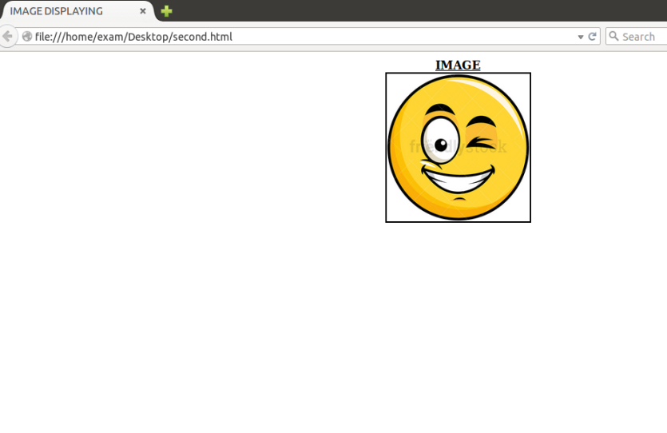

**RESULT :**

Thus, the display an image example was designed using HTML .

|  |  |
| --- | --- |
| **EX NO : 1** | **DEVELOPING STATIC WEBPAGE USING BASIC HTML** |
| **DATE :** |

**QUESTION 2 :**

Create a page which contains two links- one at the top and one at thebottom. On clicking the top link, the page has to scroll down to the bottom of the page where bottom link is present. On clicking the bottom link, the page has to scroll up to the top of the page.

**AIM :**

To develope a static webpage using HTML .

**CODE :**

**<html>**

**<head>**

**<title></title>**

**</head>**

**<body>**

**<a name="top">TOP OF THE PAGE</a>**

**<a href="#bottom">CLICK TO GO BOTTOM OF THE PAGE</a>**

**<center><img src="smiley.jpg" width="200" height="200" border="2" ></center>**

**<br><br><br><br><br><br><br><br><br><br><br><br><br><br><br><br><br><br><br><br><br><br><br><br><br><br><br><br><br><br><br><br><br>**

**<a name="bottom"> BOTTOM OF THE PAGE</a>**

**<a href="#top">CLICK TO GO TOP OF THE PAGE</a>**

**</body>**

**</html>**

**OUTPUT :**

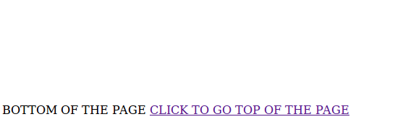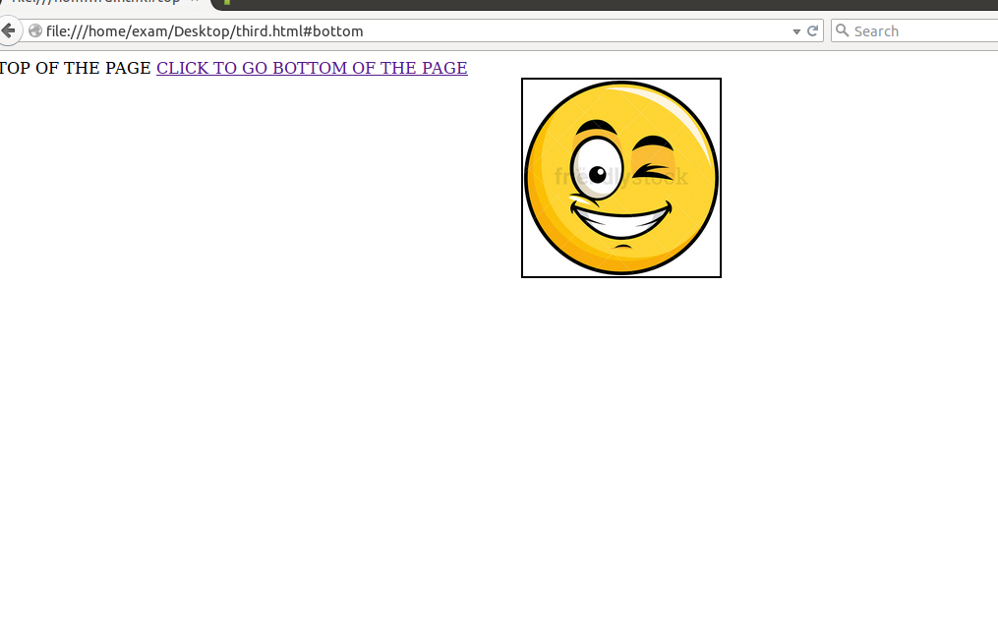

**RESULT :**

Thus, the given Bookmark example was designed using HTML .

|  |  |
| --- | --- |
| **EX NO : 1** | **DEVELOPING STATIC WEBPAGE USING BASIC HTML** |
| **DATE :** |

**QUESTION 3:**

Design Html page that display the following content.

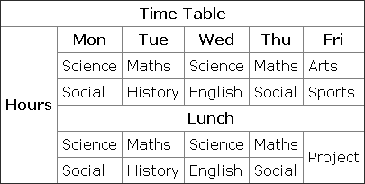

**AIM :**

To develope a static webpage using HTML .

**CODE :**

**<html>**

**<head>**

**<title>TIME TABLE</title>**

**</head>**

**<body>**

**<center><table border="1" cellspacing="0" >**

**<tr>**

**<th colspan="6">TIME TABLE</th>**

**</tr>**

**<tr>**

**<tH rowspan="6">HOURS</th>**

**<th>MON </th>**

**<th>TUE</th>**

**<th>WED</th>**

**<th>THU</th>**

**<th>FRI</th>**

**</tr>**

**<tr>**

**<td>Science</td>**

**<td>Maths</td>**

**<td>Science</td>**

**<td>Maths</td>**

**<td>Arts</td>**

**</tr>**

**<tr>**

**<td>Social</td>**

**<td>History</td>**

**<td>English</td>**

**<td>Social</td>**

**<td>Sports</td>**

**</tr>**

**<tr>**

**<th colspan="6"><b>LUNCH</b></th>**

**</tr>**

**<tr>**

**<td>Science</td>**

**<td>Maths</td>**

**<td>Science</td>**

**<td>Maths</td>**

**<td rowspan="2">Project</td>**

**</tr>**

**<tr>**

**<td>Social</td>**

**<td>History</td>**

**<td>English</td>**

**<td>Social</td>**

**</tr></center>**

**</table>**

**</body>**

**</html>**

**OUTPUT :**

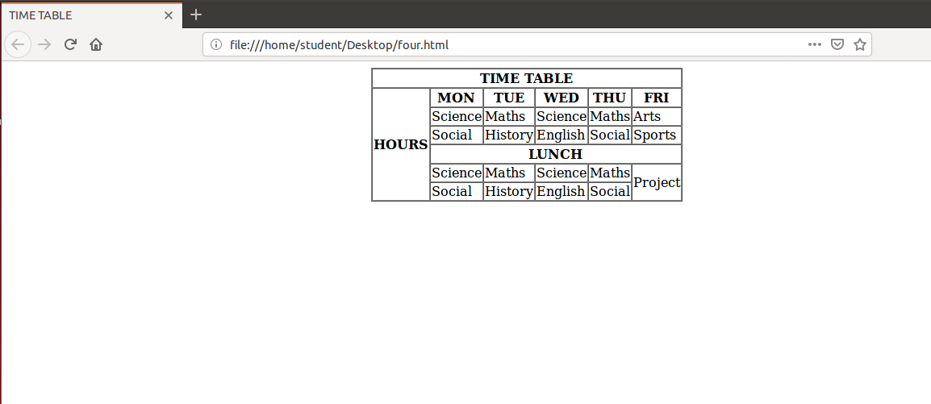

**RESULT :**

Thus, the given Table example was designed using HTML .

|  |  |
| --- | --- |
| **EX NO : 2** | **DEVELOPING STATIC WEBPAGE USING**  **HTML LISTS AND FORMS** |
| **DATE :** |

**QUESTION 1 :**

Create a webpage that prints three lists with any information you want. One list should be an ordered list and the other lists should be an unordered list and glossary list.

**AIM :**

To develope a static webpage using HTML Lists .

**CODE :**

**<html>**

**<head>**

**<title> LIST TYPES</title>**

**</head>**

**<body>**

**<CENTER><B><U>LIST TYPES</B></U></CENTER>**

**<h4>UNORDERED LIST</h4>**

**<ul>**

**<li>MECHANICAL ENGINEERING</li>**

**<li>MARINE ENGINEERING</li>**

**<li>AEROSPACE ENGINEERING</li>**

**</ul>**

**<h4>ORDERED LIST</h4>**

**<ol>**

**<li>MASTER OF BUSINESS ADMINSTRATION</li>**

**<li>MASTER OF SCIENCE</li>**

**<li>MASTER OF DOCTORATE</li>**

**</ol>**

**<h4>DEFINTION LIST</h4>**

**<dl>**

**<dt>ENGINEERING</DT>**

**<dd>MECHANICAL ENGINEERING</dd>**

**<dd>MARINE ENGINEERING</dd>**

**<dd>AEROSPACE ENGINEERING</dd>**

**<dt>MASTER DEGREE's<dt>**

**<dd>MASTER OF BUSINESS ADMINSTRATION</dd>**

**<dd>MASTER OF SCIENCE</dd>**

**<dd>MASTER OF DOCTORATE</dd>**

**</dl>**

**</body>**

**</head>**

**OUTPUT :**

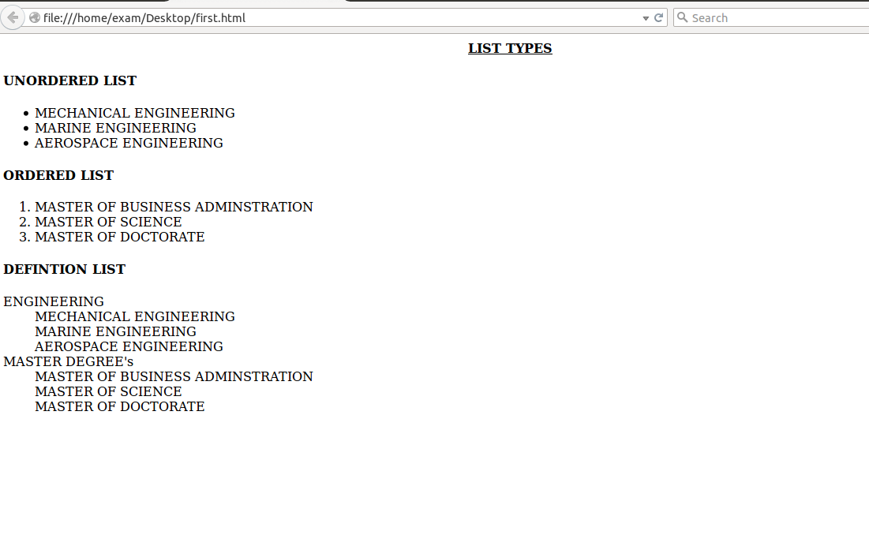

**RESULT :**

Thus, the given list example was designed using HTML Lists .

|  |  |
| --- | --- |
| **EX NO : 2** | **DEVELOPING STATIC WEBPAGE USING**  **HTML LISTS AND FORMS** |
| **DATE :** |

**QUESTION 2 :**

Design a HTML page as shown in figure using form tags.

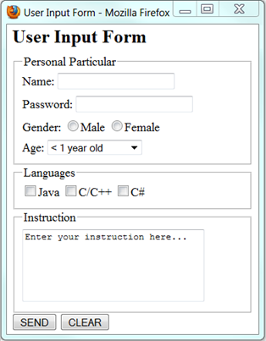

**AIM :**

To develope a static webpage using HTML Forms .

**CODE :**

**<html>**

**<head>**

**<title>User Input Form</title>**

**<fieldset>**

**<legend>Personal Particular:</legend>**

**Name:<input type="text" name="Name" ><br>**

**Password:<input type="password" name="password" ><br><br>**

**Gender:<input type="radio" Name="gender" value="Male">Male**

**<input type="radio" Name="gender" value="Female">Female <br>**

**Age:<select><option>&lt 1 year old</option>**

**<option>&lt 2 year old</option>**

**<option>&lt 3 year old</option>**

**<option>&lt 4 year old</option>**

**</select>**

**</fieldset>**

**<fieldset>**

**<legend>Languages</legend>**

**<input type="checkbox" name="Languages" value="Java" >Java<input type="checkbox" name="Languages" value="c/c++">C/C++<input type="checkbox" name="languages" value="C#" >C#**

**</fieldset>**

**<fieldset>**

**<legend>Instruction</legend>**

**<textarea placeholder="Enter your instructions here.."></textarea>**

**</fieldset>**

**<br>**

**<input type="submit" value="send">**

**<input type="reset" value="clear">**

**</head>**

**</html>**

**OUTPUT :**

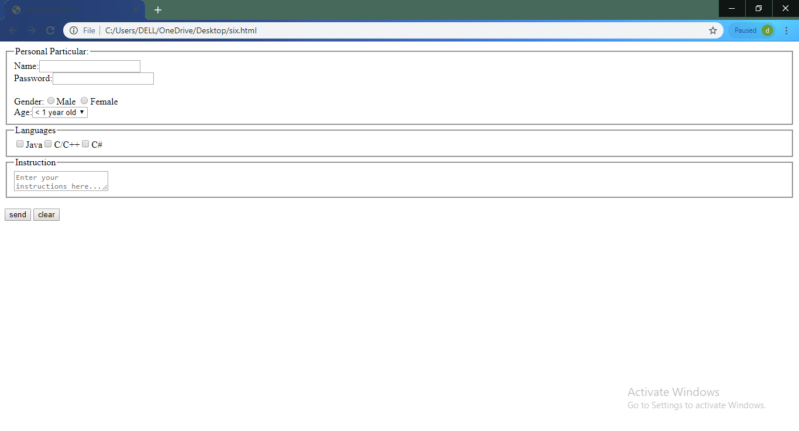

**RESULT :**

Thus, the given Form example was designed using HTML Forms .

|  |  |
| --- | --- |
| **EX NO : 3** | **DEVELOPING STATIC WEBPAGE USING HTML FRAMES** |
| **DATE :** |

**QUESTION 1 :**

Design a website for a startup company that contains the following features.

* Website should have at least three page.
* Home page should have the links to other two pages and should have frame.
* Any one page should have tables to represent the data.o Any one page should

have background image.

* Display an image that when clicked will link to a search engine of your choice

(should be opened in a new window)

* Pages with a link at the top of it that when clicked will jump all the way to the

bottom of the page. At the bottom of the page there should be a link to jump back to the top of the page.

**AIM :**

To develope a static webpage using HTML Frames .

**CODE :**

**EXE(1):**

**<html>**

**<head>**

**<title>AUTOMOBILE SPARE SHOP </title>**

**</head>**

**<frameset rows="30%,70%">**

**<frame src="exe(2).html">**

**<frame src="exe(4).html">**

**</frameset>**

**</html>**

**EXE(2):**

**<html>**

**<head>**

**<title>AUTOMOBILE SPARE PARTS</title>**

**<body align="center" background="auto1.jpg">**

**</head>**

**</html>**

**EXE(3):**

**<html>**

**<head>**

**<title>AUTOMOBILE SPARE PARTS</title>**

**</head>**

**<body>**

**<id="top">**

**<a href="#bot" align="right">Bottom</a>**

**<p><b>Aims and Motivations of the Research Study:</b></p>**

**<p>The automobile industry is a global industry which is witnessing a high level of growth. The competition in this global industry necessitates a well-coordinated process of supply of the automotive parts to car manufacturers as an when there is a demand for the same. Thereby the need to have good level of inventory management in the global supply chain is of prime importance to meet the demand of the market, help the business to survive and grow in this competitive market.**

**My motivation and aim of this research study is to comprehend all the aspects which make possible successful inventory control in global supply chain management. My area of research and analysis in this context would lay focus on the automotive parts manufacturing sector.</p>**

**<h2>Importance of Spare Parts</h2><p>Many businesses across the world deal with heavy machinery or equipment that consumes maintenance materials, and spare parts management is one of the most important considerations to take into account. Having a strong spare parts planning system in place can offer benefits across many different aspects of operations.**

**<br><br>**

**There are two major areas that need to be addressed when it comes to spare parts management. Firstly, you need an accurate and complete set of data related to the items using the parts. Secondly, you need a strong forecasting process. Combined, these two concepts create the foundation of an effective spare parts management plan.**

**<br><br>**

**Complete data is a significant need for all businesses that rely on machines large and small to complete tasks, but is most acutely felt by companies supporting high-value assets across a large geographic area.**

**<br><br>**

**Increased service level of inventory**

**One way to sum up this advantage is: you basically do more with less. The increased service level is most closely tied to the concept of right parts, right place, right time. Businesses that implement the software and systems that drive efficiency in the spare parts planning space typically see a gain in inventory service levels. Parts are more able to be put to use quickly and effectively.**

**<br><br>**

**Improved equipment uptime**

**Downtime simply due to the want of a specific part, or even an selection of different ones, is usually avoidable with a strong spare parts management system.**

**While there will be the occasional exception, in general, fix-time rate will improve considerably. This always leads to savings, but the example of individual, large and high-value assets is the most striking. With good spare parts management, time spent with assets that are unusable is reduced.</p>**

**<table border="10" align="center" style="width:80%">**

**<tr><th align="center">Dimension</th>**

**<th align="center">Criteria</th></tr>**

**<tr><td align="center">Price</td>**

**<td align="center">Price differences,payment terms,quantity discount,Product cost</td></tr>**

**<tr><td align="center">Delivery</td>**

**<td align="center">Lead time,Delivery on time every time,Distribution capacity.</td></tr>**

**<tr><td align="center">Production</td>**

**<td align="center">Inventory Management,Predictive and Preventive,Maintenance,New Product Capacity</td></tr>**

**<tr><td align="center">Technological Capability</td>**

**<td align="center">Percent of Research and development,up-to-date techniques and equipment.</td></tr>**

**</table>**

**<b> <center>THE END</center></b>**

**<h6 id="bot">**

**<a href="#top" align="right">Top</a>**

**</body>**

**</html>**

**EXE(4):**

**<html>**

**<head>**

**<title>AUTOMOBILE SPARE PARTS</title>**

**</head>**

**<frameset cols="5%,95%">**

**<frame src="exe(5).html">**

**<frame src="exe(3).html">**

**</frameset>**

**</html>**

**EXE(5):**

**<html>**

**<head>**

**<title>AUTOMOBILE SPARE PARTS</title>**

**</head>**

**<body>**

**<a href="https://www.autospareparts.com" target="_blank"><img align="right" src="download.png" height="50" width="50"></a>**

**</body>**

**</html>**

OUTPUT:

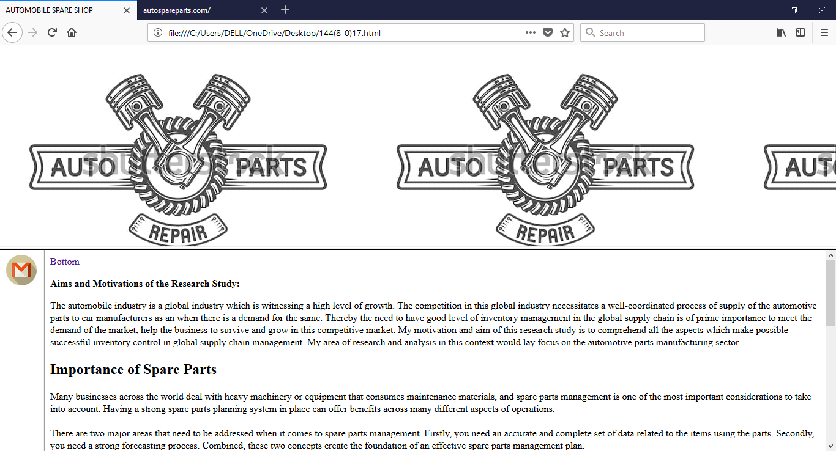

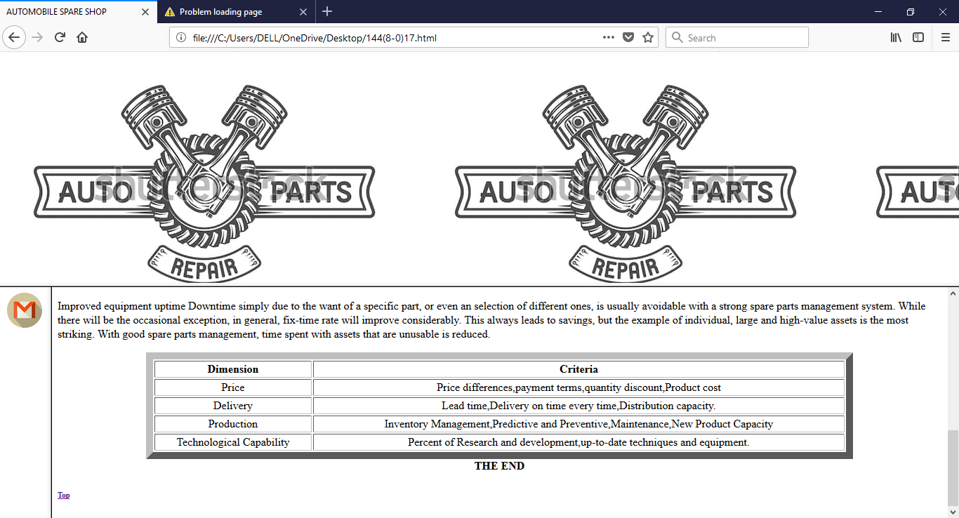

**RESULT :**

Thus, the given Frame example was designed using HTML Frames.

|  |  |
| --- | --- |
| **EX NO : 4** | **DEVELOPING STATIC WEBPAGE USING CSS CLASS SELECTOR AND CSS ID SELECTOR** |
| **DATE :** |

**QUESTION 1 :**

Create a webpage that displays the div element with the following properties.

* Alignment: Center
* Font Size : 27pixels
* Font Name: Arial

Note: Use css Id selector

**AIM :**

To develope a static webpage using CSS id selector .

**CODE :**

**<html>**

**<head>**

**<title>CSS BASICS-1</title>**

**<style>**

**#pg**

**{**

**font-family:Arial;**

**font-size:27px;**

**text-align:center;**

**}**

**</style>**

**</head>**

**<body>**

**<div id="pg">KARPAGAM COLLEGE OF ENGINEERING <br> WELCOMES YOU </div>**

**</body>**

**</html>**

**OUTPUT :**

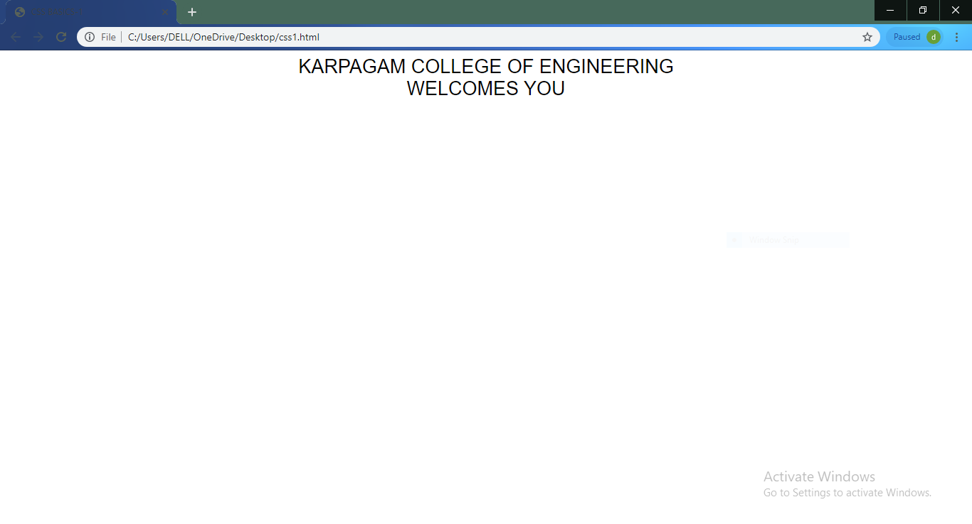

**RESULT :**

Thus, the given text example was designed using CSS Id selector.

|  |  |
| --- | --- |
| **EX NO : 4** | **DEVELOPING STATIC WEBPAGE USING CSS CLASS SELECTOR AND CSS ID SELECTOR** |
| **DATE :** |

**QUESTION 2 :**

Create a webpage that displays the div element with the following properties.

* Alignment: Center
* Font Size : 25pixels
* Font Name: Verdana

Note: Use css class selector

**AIM :**

To develope a static webpage using CSS class selector .

**CODE :**

**<html>**

**<head>**

**<title>CSS BASICS-1</title>**

**<style>**

**.pg**

**{**

**font-family:Verdana;**

**font-size:25px;**

**text-align:center;**

**}**

**</style>**

**</head>**

**<body>**

**<div class="pg">KARPAGAM COLLEGE OF ENGINEERING <br> WELCOMES YOU </div>**

**</body>**

**</html>**

**OUTPUT :**

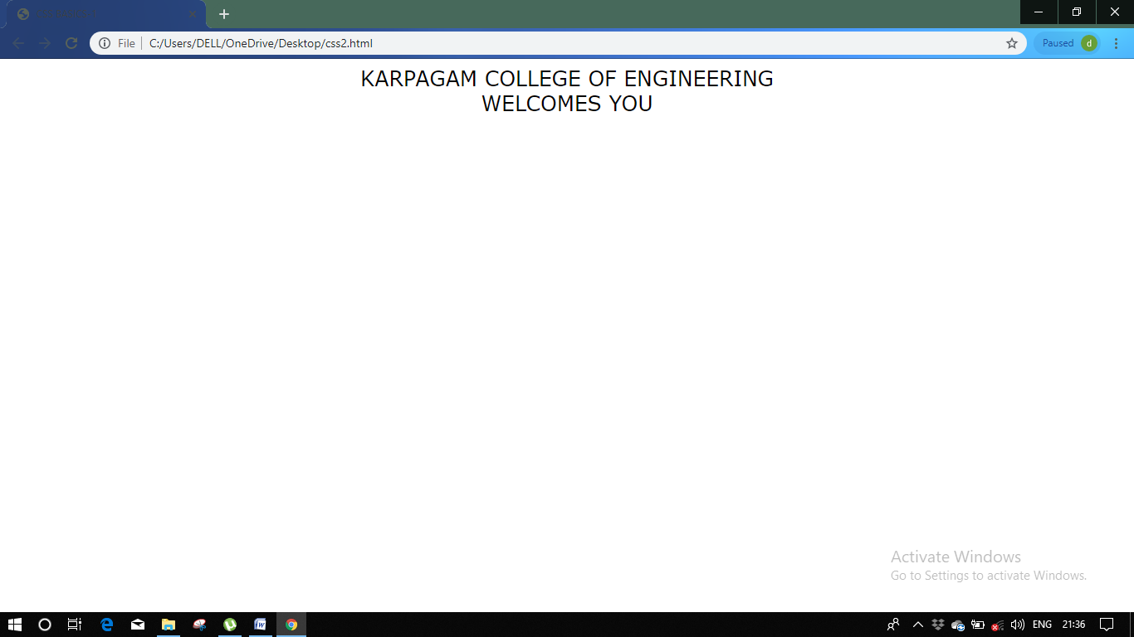

**RESULT :**

Thus, the given text example was designed using CSS Class selector.

|  |  |
| --- | --- |
| **EX NO : 5** | **DEVELOPING WEBPAGE USING EXTERNAL STYLE SHEET** |
| **DATE :** |

**QUESTION 1 :**

Create a webpage that displays the div element with the following font properties.

* Font family: Verdana
* Font style: italic
* Font size: 20pixels
* Text align: left
* Font weight: bold
* Text color: Red

Use External Style sheet

**AIM :**

To develope a webpage using External Style sheet .

**CODE :**

**css file**

**div{**

**font-family:verdana;**

**font-style:italic;**

**font-size:20px;**

**font-weight:bold;**

**text-align:left;**

**color:red;**

**}**

**HTML file**

**<html>**

**<head>**

**<title>CSS BASICS-1</title>**

**<link rel="stylesheet" type="text/css" href="sub3.css">**

**</head>**

**<body>**

**<div >KARPAGAM COLLEGE OF ENGINEERING <br> WELCOMES YOU </div>**

**</body>**

**</html>**

**OUTPUT :**

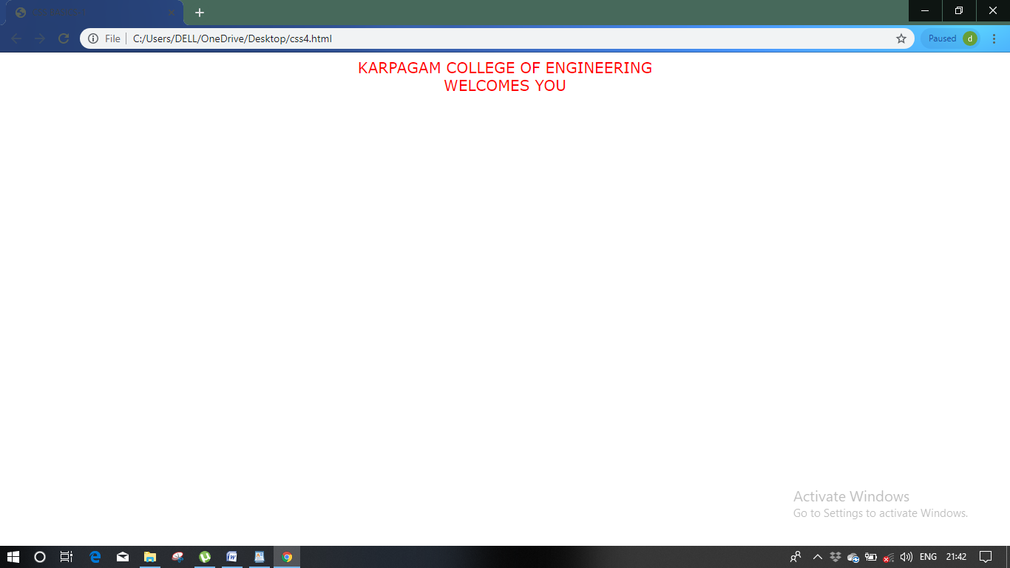

**RESULT :**

Thus, the given text example was designed using using External Style sheet .

|  |  |
| --- | --- |
| **EX NO : 6** | **DEVELOPING WEBPAGE USING INLINE STYLE**  **SHEET AND INTERNAL STYLE SHEET** |
| **DATE :** |

**QUESTION 1 :**

Create a webpage that displays the div element with the following attributes.

* Font name: Verdana
* Font size: 20 pixels
* Color: red
* Align: center

Note: Use Inline style sheet

**AIM :**

To develope a webpage using Inline Style sheet .

**CODE :**

**<html>**

**<head>**

**<title>CSS BASICS-1</title>**

**</head>**

**<body>**

**<div style="Color: red; text-Align: center;font-family:verdana;font-size:20px">KARPAGAM COLLEGE OF ENGINEERING <br> WELCOMES YOU </div>**

**</body>**

**</html>**

**OUTPUT :**



**RESULT :**

Thus, the given text example was designed using using Inline Style sheet .

|  |  |
| --- | --- |
| **EX NO : 6** | **DEVELOPING WEBPAGE USING INLINE STYLE**  **SHEET AND INTERNAL STYLE SHEET** |
| **DATE :** |

**QUESTION 2 :**

Create a webpage that displays the div element with the following text properties.

* Text color: Magenta
* Text alignment: right
* Text decoration: underline
* Text transform: uppercase
* Text indent: 60 pixels

Use Internal Style Sheet

**AIM :**

To develope a webpage using Internal Style sheet .

**CODE :**

**<html>**

**<head>**

**<title>CSS BASICS-1</title>**

**<style>**

**h4{**

**color:magenta;**

**text-align:right;**

**text-transform:uppercase;**

**text-indent:60px;**

**text-decoration:underline;**

**}**

**</style>**

**</head>**

**<body>**

**<h4>KARPAGAM COLLEGE OF ENGINEERING <br> WELCOMES YOU </h4>**

**</body>**

**</html>**

**OUTPUT :**

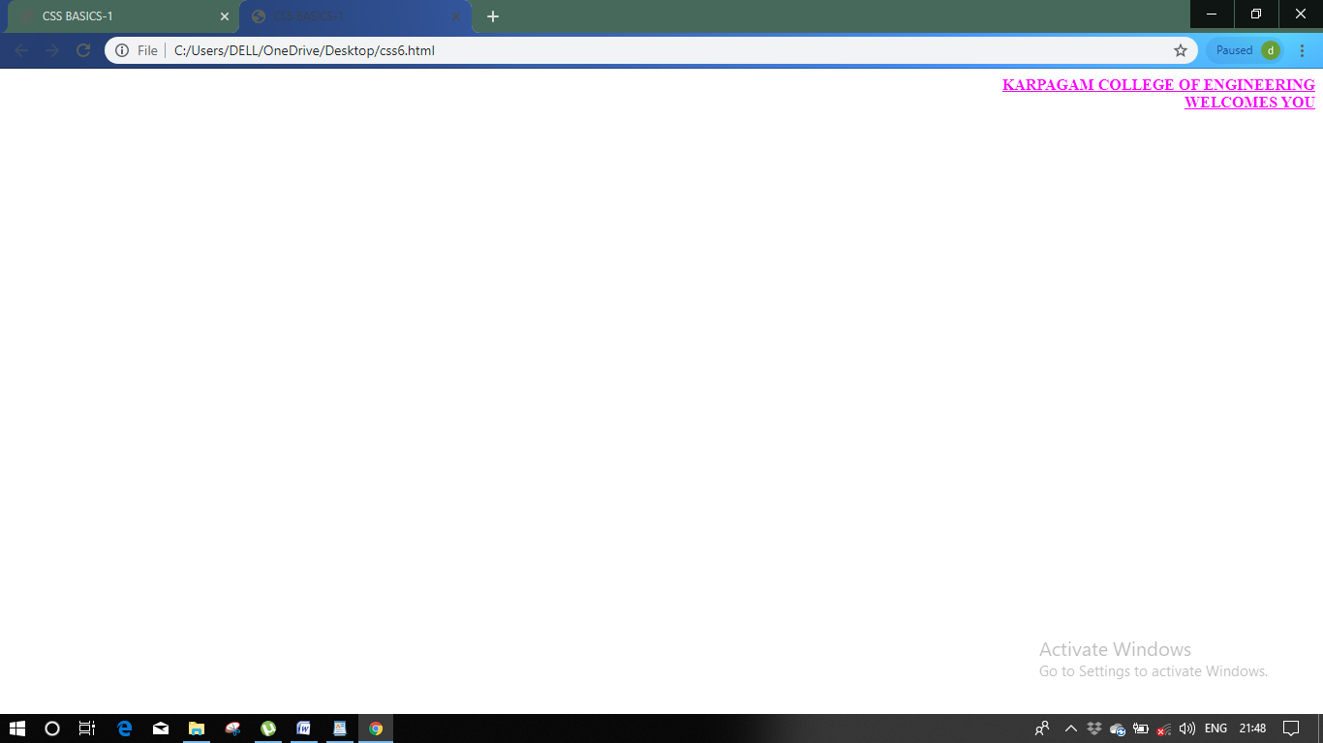

**RESULT :**

Thus, the given text example was designed using using Internal Style sheet .

|  |  |
| --- | --- |
| **EX NO : 7** | **DEVELOPING WEBPAGE USING HTML AND CSS 3** |
| **DATE :** |

**QUESTION 1 :**

Create a webpage that displays the hyperlink with the following color attributes.

* Set the color as %FF0000 for unvisited link
* Set the color as %FF00 for visited link
* Set the color as %FF00FF for mouse over link
* Set the color as %0000FF for selected link

**AIM :**

To develope a webpage using HTML and CSS 3.

**CODE :**

**<html>**

**<head>**

**<style>**

**a:link {**

**color: red;**

**}**

**a:visited {**

**color: green;**

**}**

**a:hover {**

**color: hotpink;**

**}**

**a:active {**

**color: blue;**

**}**

**</style>**

**</head>**

**<body>**

**<a href="http://www.youtube.com" target="_blank">This is a link</a>**

**</body>**

**</html>**

**OUTPUT :**

**Hover :**

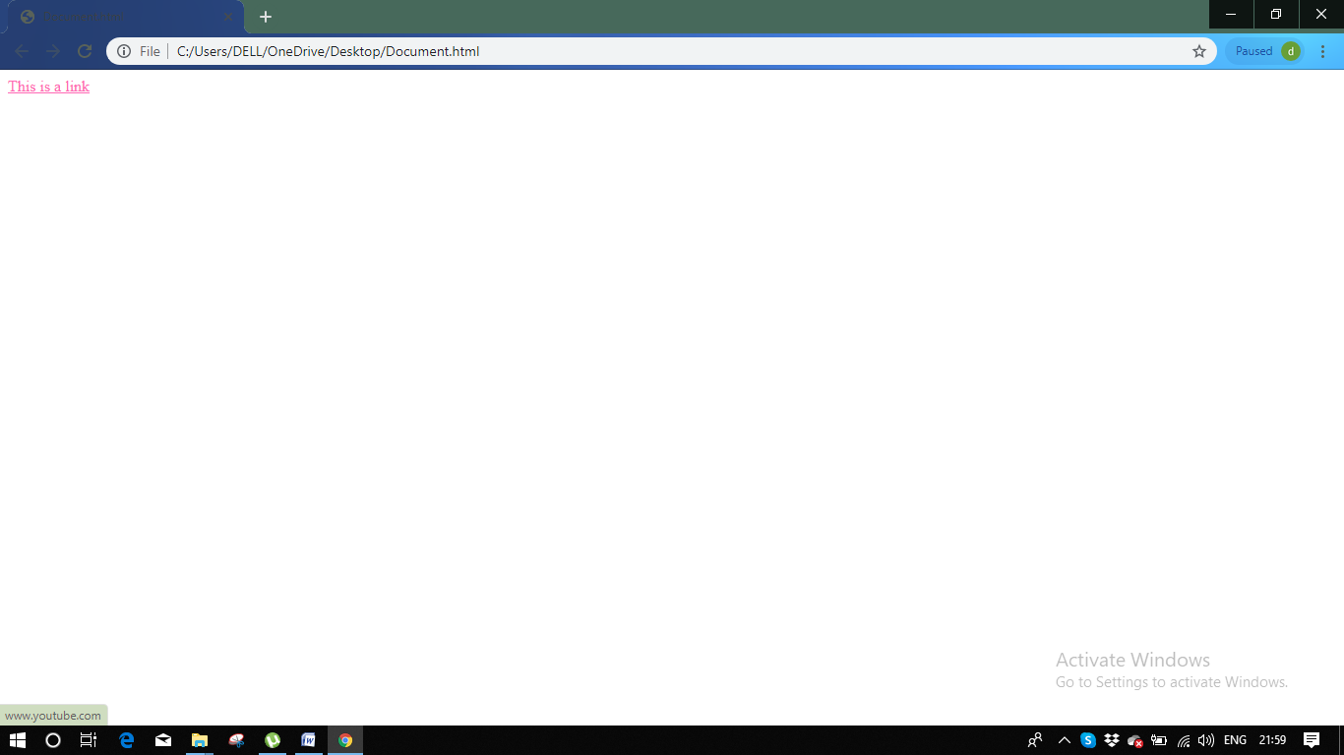

**Visited :**

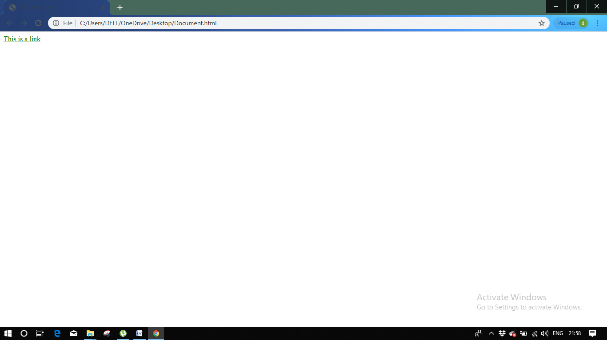

**RESULT :**

Thus, the given hyperlink example was designed using HTML and CSS 3 .

|  |  |
| --- | --- |
| **EX NO : 7** | **DEVELOPING WEBPAGE USING HTML AND CSS 3** |
| **DATE :** |

**QUESTION 2 :**

Create a webpage that displays a list as an ordered list with the following properties.

* List-style-type: lower-greek;
* Text align: left
* Color: red
* Text transform: uppercase
* Text decoration: underline
* Font name: Verdana
* Font size: 20pixels
* Font weight: bold

**AIM :**

To develope a webpage using HTML and CSS 3.

**CODE :**

|  |  |
| --- | --- |
|  | <html> |
|  | <head> |
|  | <style> |
|  | #hi{ |
|  | List-style-type: lower-greek; |
|  | Text-align: left; |
|  | Color: red; |
|  | Text-transform: uppercase; |
|  | Text-decoration: underline; |
|  | Font-name: Verdana; |
|  | Font-size: 20pixels; |
|  | weight: bold; |
|  | } |
|  | </style> |
|  | </head> |
|  | <body> |
|  | <ol id="hi"> |
|  | <li>COIMBATORE</li> |
|  | <li>CHENNAI</li> |
|  | <li>TRICHY</li> |
|  | <li>MADURAI</li> |
|  | </ol> |
|  | </body> |
|  | </html> |

**OUTPUT :**

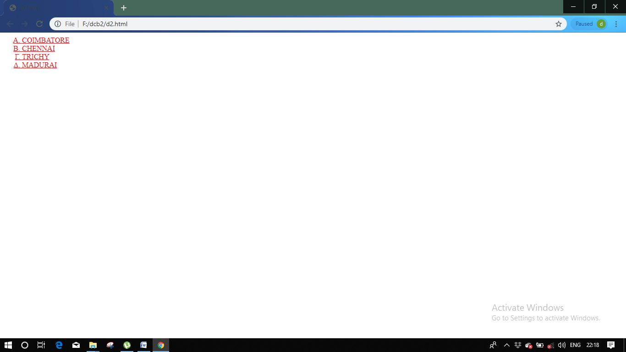

**RESULT :**

Thus, the given text example was designed using HTML and CSS 3 .

|  |  |
| --- | --- |
| **EX NO : 7** | **DEVELOPING WEBPAGE USING HTML AND CSS 3** |
| **DATE :** |

**QUESTION 3 :**

Create a webpage that displays the paragraph with the following properties.

* Set the width of the border as 10 Pixels.
* Set the style of the border as dotted.
* Set the color of the border as #0000ff

**AIM :**

To develope a webpage using HTML and CSS 3.

**CODE :**

**<html>**

**<head>**

**<style>**

**p.bod {**

**border-style: dotted;**

**border-color: green;**

**border-width:20px;**

**}**

**</style>**

**</head>**

**<body>**

**<p class="bod">The paragraph with the following properties has been displayed.</p>**

**</body>**

**</html>**

**OUTPUT :**

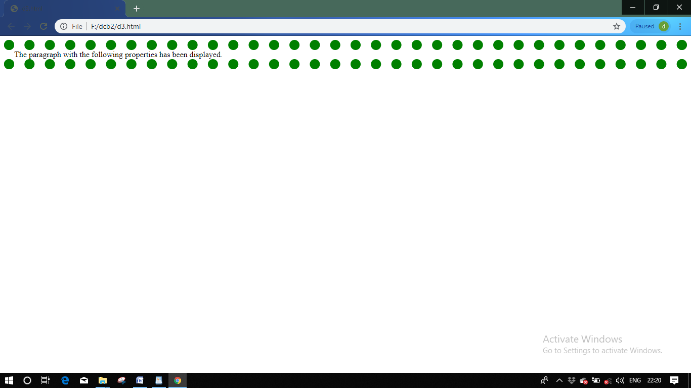

**RESULT :**

Thus, the given border example was designed using HTML and CSS 3 .

|  |  |
| --- | --- |
| **EX NO : 8** | **DEVELOPING WEBPAGE USING HTML AND CSS 3** |
| **DATE :** |

**QUESTION 1 :**

Create a webpage that displays three paragraphs with the following margin properties.

* Set the top margin as 3cm for first paragraph
* Set the bottom margin as 5cm for first paragraph
* Set the left margin as 2cm for second paragraph
* Set the top margin as 25% for third paragraph

**AIM :**

To develope a webpage using HTML and CSS 3.

**CODE :**

**<html>**

**<head>**

**<style>**

**#a{**

**border: 1px solid black;**

**margin-top: 113px;**

**margin-bottom: 189px;**

**}**

**#b{**

**border: 1px solid black;**

**margin-top: 75px;**

**}**

**#c{**

**border: 1px solid black;**

**margin-left: 4px;**

**}**

**</style>**

**</head>**

**<body>**

**<p id="a">This is a first para.</p>**

**<p id ="c">This is a second para.</p>**

**<p id="b">This is a third para.</p>**

**</body>**

**</html>**

**OUTPUT :**

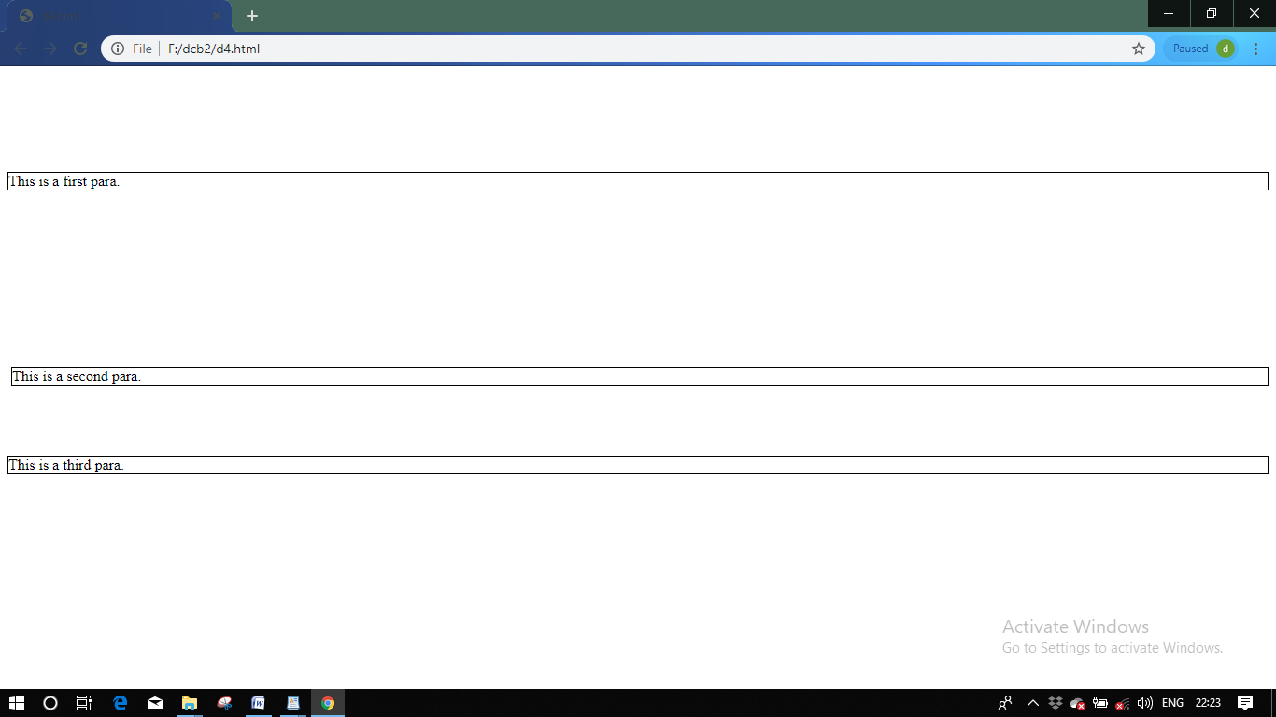

**RESULT :**

Thus, the given margin example was designed using HTML and CSS 3 .

|  |  |
| --- | --- |
| **EX NO : 8** | **DEVELOPING WEBPAGE USING HTML AND CSS 3** |
| **DATE :** |

**QUESTION 2 :**

Create a webpage that displays an image as the background around an element with the following properties.

* Border: 1pixels solid black
* Height: 150pixels
* Width: 180pixels
* Background : url (imagename.gif)
* Background-repeat: no-repeat
* Background-size: cover

**AIM :**

To develope a webpage using HTML and CSS 3.

**CODE :**

|  |  |
| --- | --- |
|  | **<html>** |
|  | **<head>** |
|  | **<style>** |
|  | **#img {** |
|  | **border:1pixels solid black;** |
|  | **height:150px;** |
|  | **width:180px;** |
|  | **background-size:cover;** |
|  | **background-image: url('index.jpg');** |
|  | **background-repeat: no-repeat;** |
|  | **}** |
|  | **</style>** |
|  | **</head>** |
|  | **<body id="img"></body></html>** |
|  |  |

**OUTPUT :**

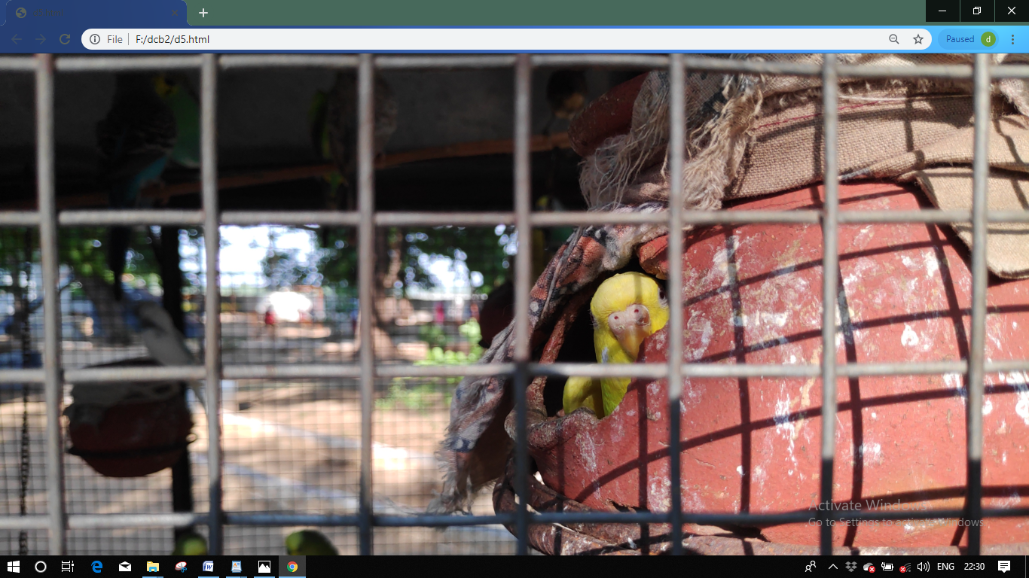

**RESULT :**

Thus, the given image example was designed using HTML and CSS 3 .

|  |  |
| --- | --- |
| **EX NO : 9** | **DEVELOPING WEBPAGE USING BOOSTRAP** |
| **DATE :** |

**QUESTION 1 :**

Create a webpage to display Tulips.jpg from sample pictures of your machine. Ensure the image has soft round edges and as you resize the screen, the image should also resize itself and fit its display to full page size.

**AIM :**

To develope a webpage using Boostrap .

**CODE :**

**<!DOCTYPE html>**

**<html>**

**<head>**

**<title>Title</title>**

**<link rel="stylesheet"href="https://maxcdn.bootstrapcdn.com/bootstrap/4.3.1/css/ bootstrap.min.css">**

**</head>**

**<body>**

**<img src="flowers.jpg" class="rounded" alt="Image is Here!" width="50%" height="60%">**

**</body>**

**</html>**

**OUTPUT :**

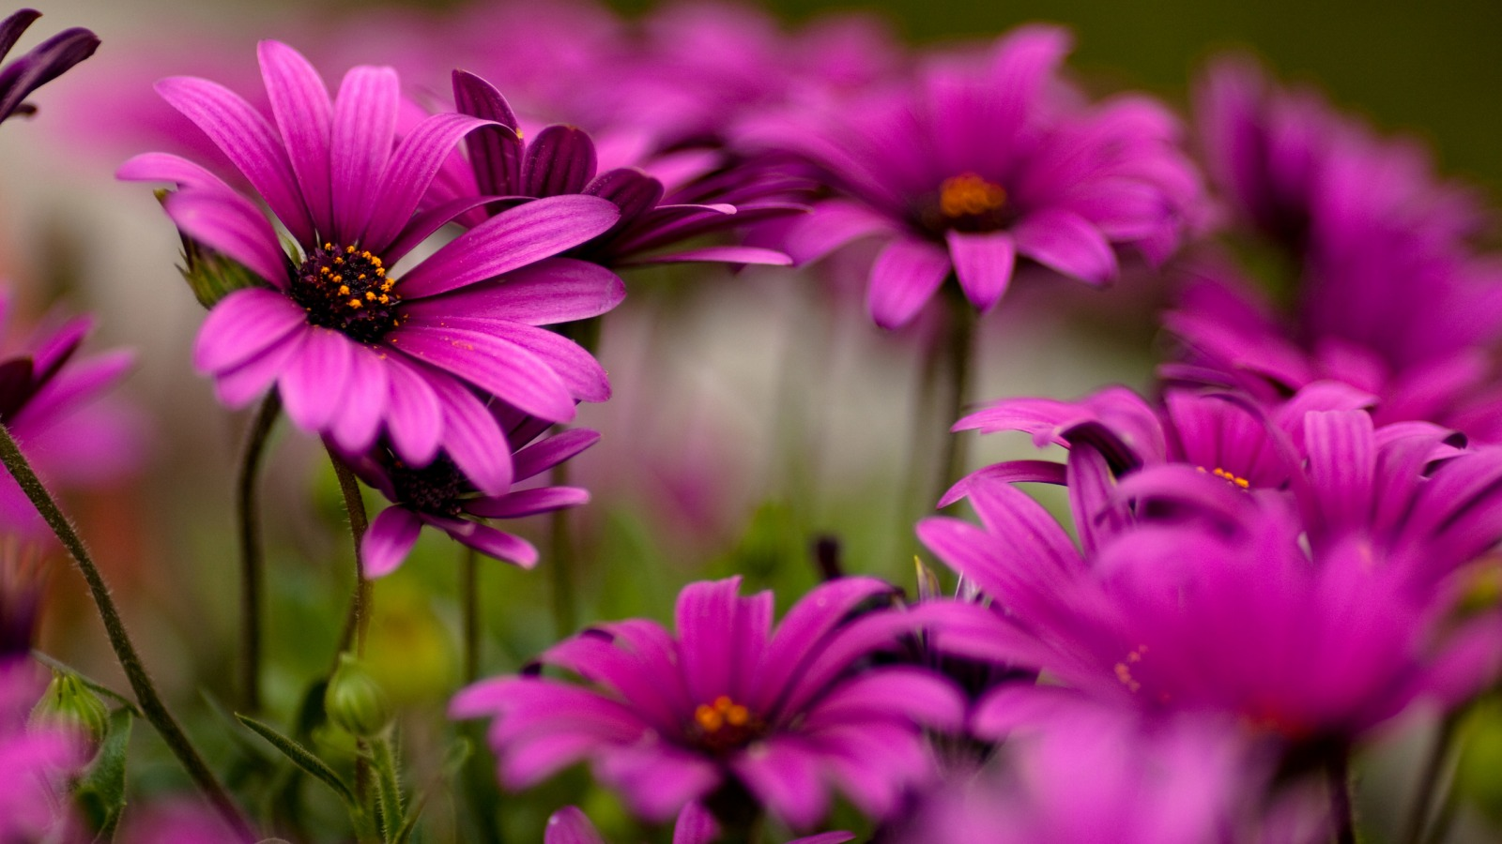

**RESULT :**

Thus, the given image example was designed using Boostrap .

|  |  |
| --- | --- |
| **EX NO : 9** | **Developed WEBPAGE USING BOOSTRAP** |
| **DATE :** |

**QUESTION 2 :**

Create a webpage called OnlineRead with give look and feel Page should display Book Types as buttons with given background effect:

* For All – white
* Kids – bark blue
* Teens – Green
* Scientific – Light Blue
* Crime – OrangeHorror – red
* Feedback – shown

In next line display the comfort font size with buttons of varying sizes ranging from big to small (in 4 steps).

**AIM :**

To develope a webpage using Boostrap .

**CODE :**

|  |  |
| --- | --- |
|  | **<html>** |
|  | **<head>** |
|  | **<title>Online_Read</title>** |
|  | **<link rel="stylesheet" href="**[**https://maxcdn.bootstrapcdn.com/bootstrap/4.3.1/css/bootstrap.min.css**](https://maxcdn.bootstrapcdn.com/bootstrap/4.3.1/css/bootstrap.min.css)**">** |
|  | **<style>** |
|  | **.btns{ display:block; margin-left: 25%; }** |
|  | **</style>** |
|  | **</head>** |
|  | **<body>** |
|  | **<br>** |
|  | **<div class="btns">** |
|  | **<button type="button" class="btn btn-success">Teens</button><br><br>** |
|  | **<button type="button" class="btn btn-secondary">Kids</button><br><br>** |
|  | **<button type="button" class="btn btn-warning">Crime</button><br><br>** |
|  | **<button type="button" class="btn btn-light">For_All</button><br><br>** |
|  | **<button type="button" class="btn btn-info">Scientific</button><br><br>** |
|  | **<textarea name="commentbox"rows="4" cols="45"> Please Enter Your Comment!!**  **</textarea> </div>** |
|  | **</body>** |
|  | **</html>** |
|  |  |

**OUTPUT :**

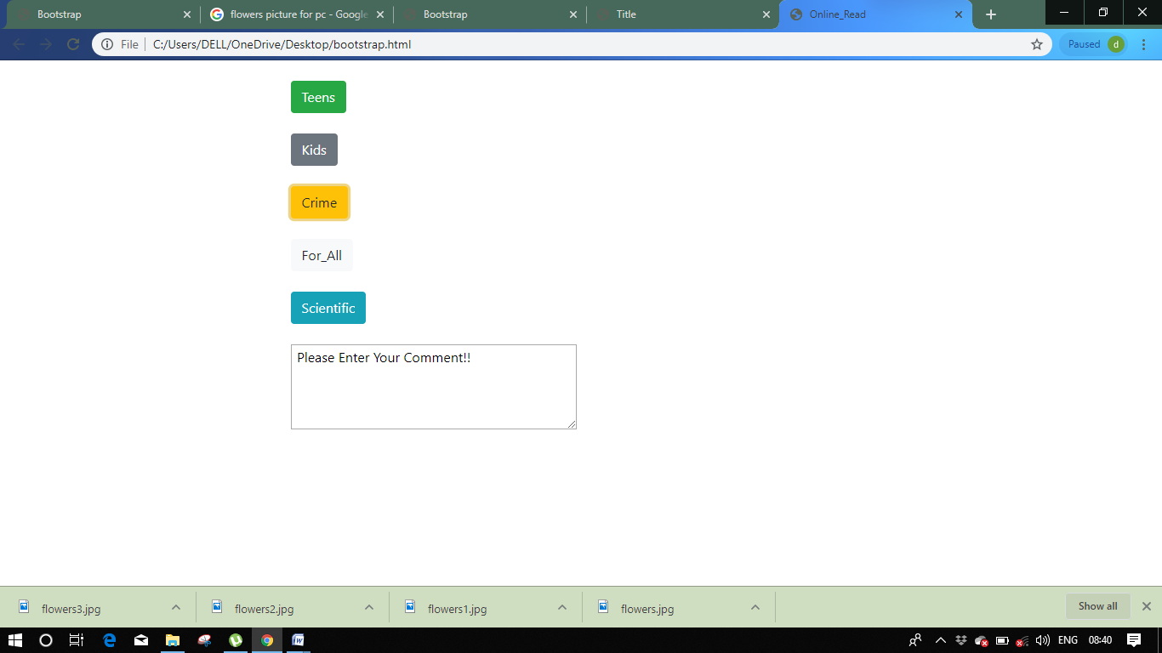

**RESULT :**

Thus, the given button example was designed using Boostrap .

|  |  |
| --- | --- |
| **EX NO : 10** | **Developed WEBPAGE WITH TABLES USING BOOSTRAP** |
| **DATE :** |

**QUESTION 1:**

Create a small table with 2 columns Name and contact no, Populate the table with 5 of your friends names and their contact nos. When the mouse is taken over the table it should highlight the row where the mouse is placed.(hint : use table hover)

**AIM :**

To develope a webpage with tables using Boostrap .

**CODE :**

**<html>**

**<head>**

**<link rel="stylesheet" href="https://maxcdn.bootstrapcdn.com/bootstrap/3.4.0/css/bootstrap.min.css">**

**<style type="text/css"> tbody tr:hover{ background-color: #ff3374; }**

**</style>**

**</head>**

**<body>**

**<table class="table">**

**<thead>**

**<tr>**

**<th>NAME</th>**

**<th>CONTACT_NO</th>**

**</tr>**

**</thead>**

**<tbody>**

**<tr>**

**<td>Loyola</td>**

**<td>964539274</td>**

**</tr>**

**<tr>**

**<td>Kishore</td>**

**<td>945272735</td>**

**</tr>**

**<tr>**

**<td>Jack Jerry</td>**

**<td>9654637287</td>**

**</tr>**

**<tr>**

**<td>Dhinesh</td>**

**<td>964354637373</td>**

**</tr>**

**<tr>**

**<td>alter</td>**

**<td>9486292369</td>**

**</tr>**

**</tbody>**

**</table>**

**</body>**

**</html>**

**OUTPUT :**

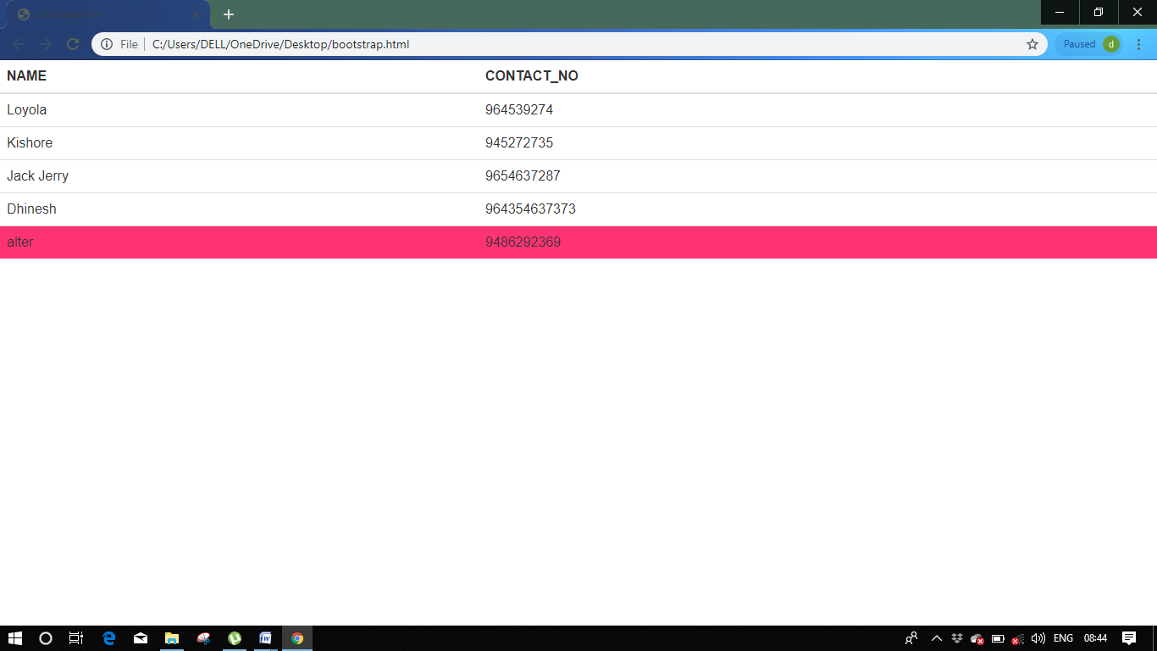

**RESULT :**

Thus, the given table example was designed using Boostrap .

|  |  |
| --- | --- |
| **EX NO : 10** | **Developed WEBPAGE WITH TABLES USING BOOSTRAP** |
| **DATE :** |

**QUESTION 2:**

Create a table of food contents with its calorie value. Display the rows of food contents with calories

* <=300 in light green background,
* 301 to 700 in light blue,
* 700 - 1200 in light orange
* >1200 in light red.

(Hint: use table table-striped)

**AIM :**

To develope a webpage with tables using Boostrap .

**CODE :**

**<html>**

**<head>**

**<title>Title</title>**

**<link rel="stylesheet" href="https://maxcdn.bootstrapcdn.com/bootstrap/4.3.1/css/bootstrap.min.css">**

**</head>**

**<body>**

**<table class="table table-striped">**

**<thead>**

**<th>Food_Contents</th>**

**<th>Calorie_Value</th>**

**</thead>**

**<tbody>**

**<tr style="background-color: #00FF7F">**

**<td>Rasgulla</td>**

**<td>140</td>**

**</tr>**

**<tr style="background-color: #ADD8E6">**

**<td>Baked Beans</td>**

**<td>310</td>**

**</tr>**

**<tr style="background-color: #FFA500">**

**<td>Briyani</td> <td>750</td>**

**</tr> <tr style="background-color: #FA8072">**

**<td>Chicken</td> <td>1300</td>**

**</tr> <tr style="background-color: #00FF7F">**

**<td>Carrot Halwa</td>**

**<td>165</td>**

**</tr>**

**<tr style="background-color: #FA8072">**

**<td>Beef Briyani</td>**

**<td>1600</td>**

**</tr>**

**<tr style="background-color: #FFA500">**

**<td>Dosa(Masala)</td>**

**<td>725</td>**

**</tr> <tr style="background-color:#ADD8E6">**

**<td>Cake(Rich Chocolate)</td>**

**<td>420</td>**

**</tr>**

**</tbody>**

**</table>**

**</body>**

**</html>**

**OUTPUT :**

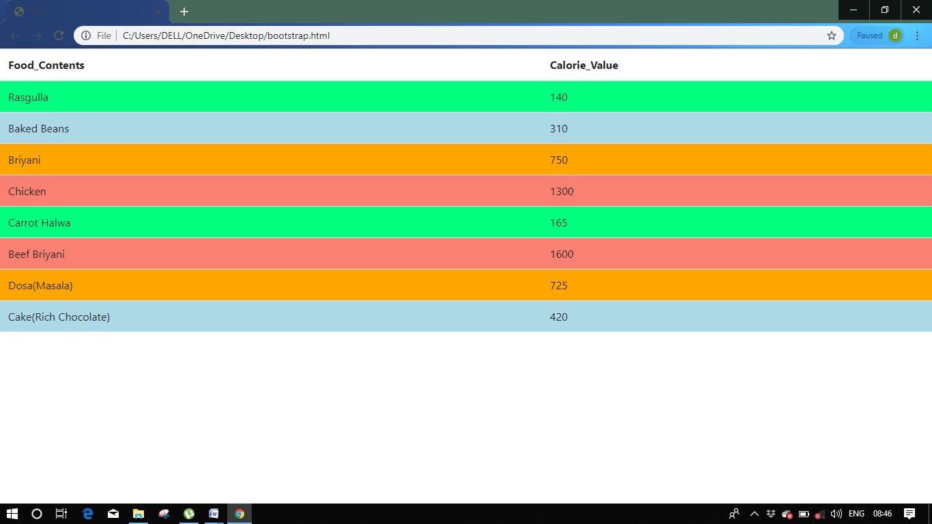

**RESULT :**

Thus, the given table example was designed using Boostrap .

|  |  |
| --- | --- |
| **EX NO : 11** | **CREATE A WEBPAGE TO RESIZE**  **BROWSER USING BOOSTRAP** |
| **DATE :** |

**QUESTION 1:**

Create a webpage which displays different images on screen as you resize the browser

Take 4 images like img1.jpg , img2.jpg, img3.jpg , img4.jpg which should be displayed on the web page and only one should be visible at any time as you keep resizing the screen it should start changing to img2 and then to img3 and so on.

**AIM :**

To create a webpage to resize browser using Boostrap .

**CODE :**

**<html>**

**<head>**

**<title>Bootstrap </title>**

**<link rel="stylesheet" href="https://maxcdn.bootstrapcdn.com/bootstrap/4.3.1/css/bootstrap.min.css">**

**</head>**

**<body>**

**<picture>**

**<source media="(min-width: 1200px)" srcset="g1.jpg" width="70%" height="80%">**

**<source media="(min-width: 1000px)" srcset="g2.jpg" width="70%" height="80%">**

**<source media="(min-width: 800px)" srcset="g3.jpg" width="70%" height="80%">**

**<img src="g4.jpg" alt="Ima is here" width="70%" height="80%">**

**</picture>**

**</body>**

**</html>**

**OUTPUT :**









**RESULT :**

Thus, the given table example was designed using Boostrap .

|  |  |
| --- | --- |
| **Ex no: 12** | **Developing a webpage using javascript** |
| **Date :** |

**Question:1**

Write a JavaScript function to find the sum of first n odd numbers and display the Result:.Get the

value of n from the user

**Aim::**

To Write a JavaScript function to find the sum of first n odd numbers and display the Result:.Get the

value of n from the user

**Code::**

|  |  |
| --- | --- |
|  | **<!DOCTYPE html>** |
|  | **<html>** |
|  | **<head>** |
|  | **<title>SUM OF N ODD NUMBERS</title>** |
|  | **</head>** |
|  | **<body>** |
|  | **<script type="text/javascript">** |
|  | **function Sum_Odd() {** |
|  | **var c=0;** |
|  | **n=Number(document.getElementById("N").value);** |
|  | **for(i=1;i<=n;i++)** |
|  | **{** |
|  | **if(i%2 != 0)** |
|  | **c=c+1;** |
|  | **}** |
|  | **window.alert("SUM OF " + n + " ODD NUMBERS: " + c*c);** |
|  | **}** |
|  | **</script>** |
|  | **<h1>SUM OF N ODD NUMBERS</h1>** |
|  | **<br><br>** |
|  | **ENTER THE NUMBER : <input type="text" name="n" id="N"/>** |
|  | **<center><button onClick="Sum_Odd()">CLICK</button>** |
|  | **</body>** |
|  | **</html>** |

**Output:**

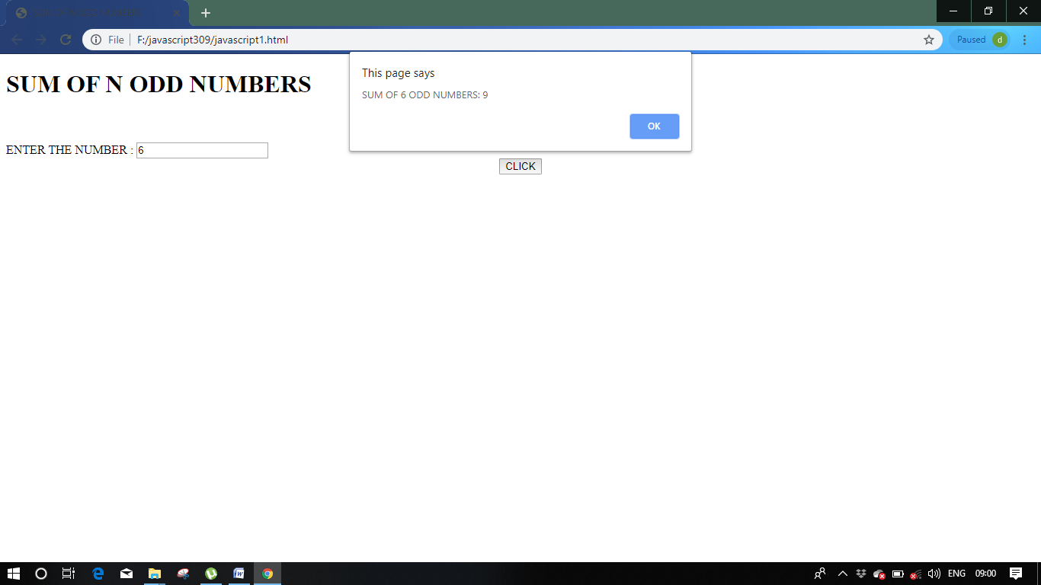

**Result:**

Hence we successfully Developed a webpage using javascript

|  |  |
| --- | --- |
| **Ex no: 12** | **Developing a webpage using javascript** |
| **Date :** |

**Question:2**

Write a JavaScript function that checks occurence of substring in a given string

**Aim:**

To Write a JavaScript function that checks occurence of substring in a given string

**Code:**

**<!DOCTYPE html>**

**<html>**

**<head>**

**<title>SubString</title>**

**</head>**

**<body>**

**<script type="text/javascript">**

**function substring() {**

**str1= String(document.getElementById("str").value);**

**substr= String(document.getElementById("sub_str").value);**

**var res = str1.match(substr);**

**if (res != null){**

**window.alert("Present");**

**}**

**else{**

**window.alert("Not Present");**

**}**

**}**

**</script>**

**<h3>OCCURRENCE OF SUB STRING OR NOT </h3>**

**<br><br><pre>**

**ENTER THE STRING : <input type="text" name="st" id="str"/><br>**

**ENTER THE SUB_STRING : <input type="text" name="substr" id="sub_str"/>**

**<center><button onClick="substring()">CHECK</button>**

**</pre>**

**</body>**

**</html>**

**Output**

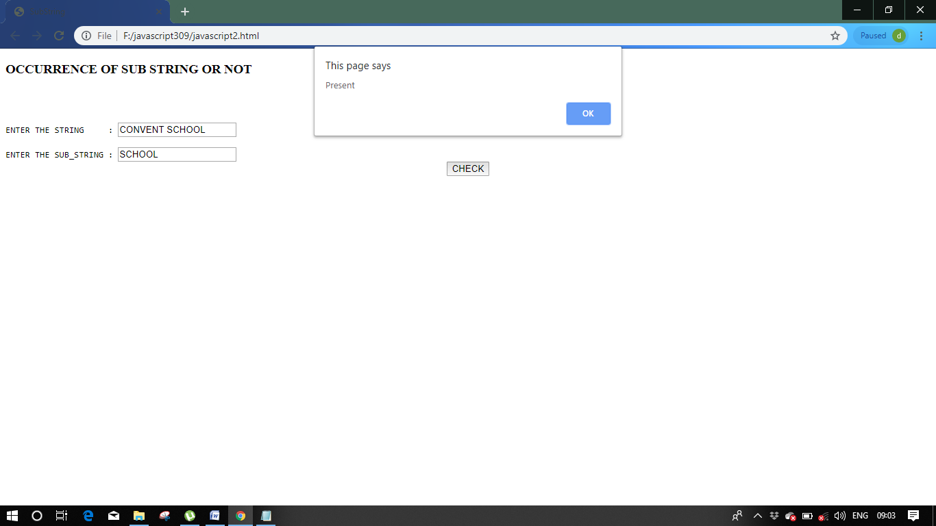

**Result:**

Hence we successfully Developed a webpage using javascript

|  |  |
| --- | --- |
| **Ex no: 12** | **Developing a webpage using javascript** |
| **Date :** |

**Question:3**

Write a JavaScript function that accepts a string as a parameter and converts the first letter of

each word of the string in upper case

**Aim:**

To Write a JavaScript function that accepts a string as a parameter and converts the first letter of

each word of the string in upper case

**Code:**

**<!DOCTYPE html>**

**<html>**

**<head>**

**<title>UPPER</title>**

**</head>**

**<body>**

**<script type="text/javascript">**

**function upper() {**

**str1= String(document.getElementById("str1").value);**

**var x=str1.split(" ");**

**for(var i=0;i<x.length;i++)**

**{**

**document.write(x[i][0].toUpperCase());**

**for(var j=1;j<x[i].length;j++)**

**{**

**document.write(x[i][j]);**

**}**

**document.write(" ");**

**}**

**}**

**</script>**

**<h3>CONVERTS FIRST LETTER OF A EACH WORD OF THE STRING IN UPPER CASE</h3>**

**<br><br>**

**ENTER THE STRING:<input type="text" name="str1" id="str1"/><br>**

**<center><button onClick="upper()">CONVERT</button>**

**</body>**

**</html>**

**Output:**

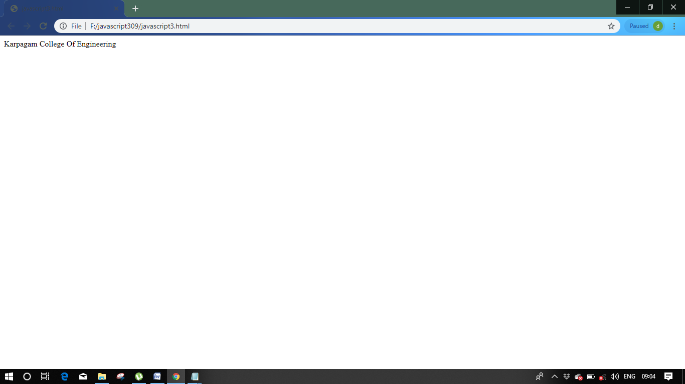

**Result:**

Hence we successfully Developed a webpage using javascript

|  |  |
| --- | --- |
| **Ex no: 13** | **Developing webpage using javascript** |
| **Date :** |

**Question:1**

Write a JavaScript program that displays the position of the first occurrence of "World" in the

variable txt

**Aim:**

To Write a JavaScript program that displays the position of the first occurrence of "World" in the

variable txt

**Code:**

**<!DOCTYPE html>**

**<html>**

**<head>**

**<title>OCCURRENCE</title>**

**</head>**

**<body>**

**<script type="text/javascript">**

**function occurrence() {**

**str1= String(document.getElementById("str1").value);**

**s_str= String(document.getElementById("s_str").value);**

**window.alert("First Occurrence of the " + s_str + " in the " + str1 + " is " + str1.search(s_str));**

**}**

**</script>**

**<h3>POSITION OF FIRST OCCURRENCE OF GIVEN WORD</h3>**

**<br>**

**ENTER THE STRING : <input type="text" name="st" id="str1"/><br>**

**ENTER THE SEARCH_STRING : <input type="text" name="sear_st" id="s_str"/>**

**<center><button onClick="occurrence()">FIND</button>**

**</body>**

**</html>**

**Output**

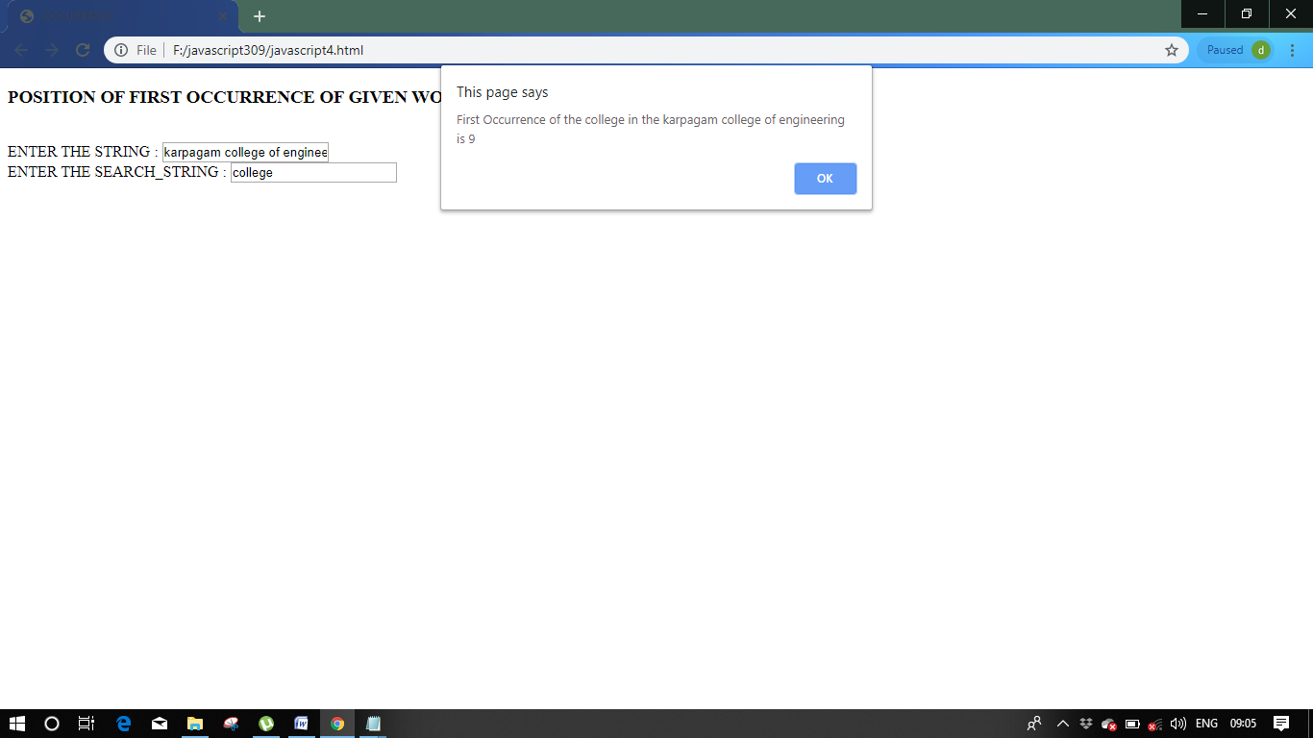

**Result:**

Hence we successfully Developed a webpage using javascript

|  |  |
| --- | --- |
| **Ex no: 13** | **Developing a webpage using javascript** |
| **Date :** |

**Question:2**

Write a JavaScript function to remove specified number of characters from a string

**Aim:**

To Write a JavaScript function to remove specified number of characters from a string

**Code:**

**<!DOCTYPE html>**

**<html>**

**<head>**

**<title>Remove</title>**

**</head>**

**<body>**

**<script type="text/javascript">**

**function Remove() {**

**str1= String(document.getElementById("str1").value);**

**n= Number(document.getElementById("n").value);**

**if(str1.length > n){**

**var x=str1.length-n-1;**

**for(var i=0;i<=x;i++){**

**document.write(str1[i]);**

**}**

**}**

**else{**

**document.write("Please Enter Valid number of characters to be removed");**

**}**

**}**

**</script>**

**<h3>REMOVE CHARACTERS FROM A STRING </h3>**

**<br><br><pre>**

**ENTER THE STRING: <input type="text" name="str1" id="str1"/><br>**

**ENTER NO.OF.CHARACTERS TO REMOVE : <input type="text" name="n" id="n"/><br><br>**

**<center><button onClick="Remove()">REMOVE</button></center></pre>**

**</body>**

**</html>**

**Output**

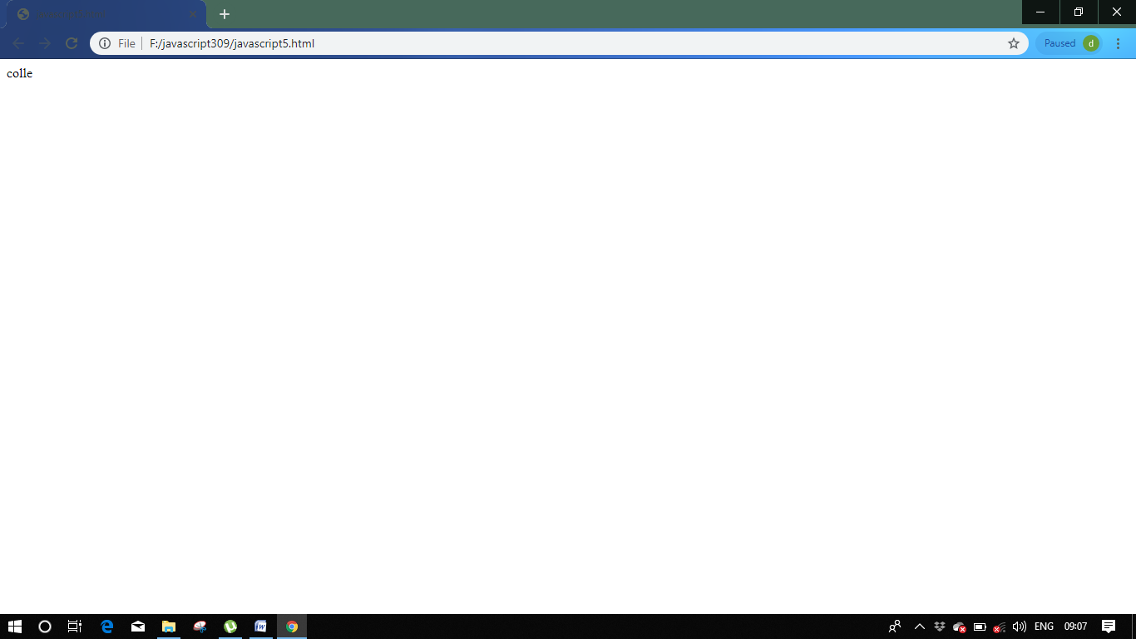

**Result:**

Hence we successfully Developed a webpage using javascript

|  |  |
| --- | --- |
| **Ex no: 13** | **Developing a webpage using javascript** |
| **Date :** |

**Question:3**

Create an HTML page with a textbox and a command button:When the user gives a number and presses the Calculate button, it has to alert the sum.

**Aim:**

To Create an HTML page with a textbox and a command button:When the user gives a number and presses the Calculate button, it has to alert the sum.

**Code:**

**<!DOCTYPE html>**

**<html>**

**<head>**

**<title>SUM OF GIVEN NUMBER</title>**

**</head>**

**<body>**

**<script type="text/javascript">**

**function Sum_num() {**

**n= Number(document.getElementById("n").value);**

**window.alert("SUM OF GIVEN NUMBER IS: \n" + (n*(n+1))/2);**

**}**

**</script>**

**<h3>SUM OF GIVEN NUMBERS </h3>**

**<br><br><pre>**

**ENTER THE NUMBER : <input type="text" name="n" id="n"/>**

**<center><button onClick="Sum_num()">SUM</button></pre>**

**</body>**

**</html>**

**Output**

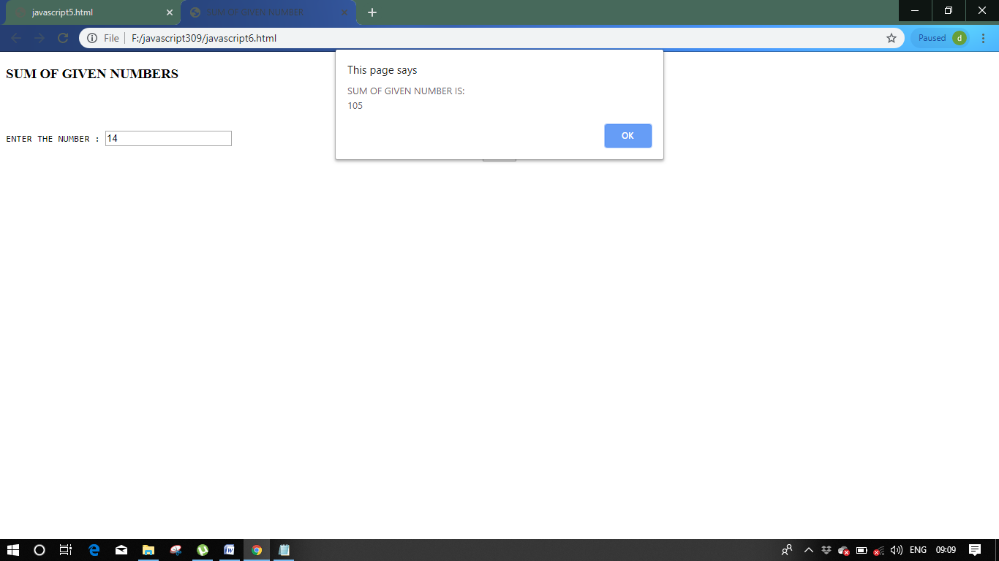

**Result:**

Hence we successfully Developed a webpage using javascript

|  |  |
| --- | --- |
| **Ex no: 14** | **Developing a webpage using Regular Expression** |
| **Date :** |

**Question:1**

Write a JavaScript program to check an Aadhar number(Format :9999-9999-9999)

**Aim:**

To Write a JavaScript program to check an Aadhar number(Format :9999-9999-9999)

**Code:**

**<!DOCTYPE html>**

**<html>**

**<head>**

**<title>Aadhaar number </title>**

**</head>**

**<body>**

**<script type="text/javascript">**

**function Aadhaar_number()**

**{**

**number= String(document.getElementById("number").value);**

**var val_num= /^(\d{4}-)+(\d{4}-)+(\d{4})$/;**

**var res =val_num.exec(number);**

**if(res)**

**{**

**window.alert("Aadhaar Number is Valid");**

**}**

**else{**

**window.alert("Aadhaar Number is Invalid \n PLEASE CHECK");**

**}**

**}**

**</script>**

**ENTER THE AADHAAR NUMBER : <input type="text" name="number" id="number"/>**

**<center><button onClick="Aadhaar_number()">SUBMIT</button></center>**

**</body>**

**</html>**

**Output:**

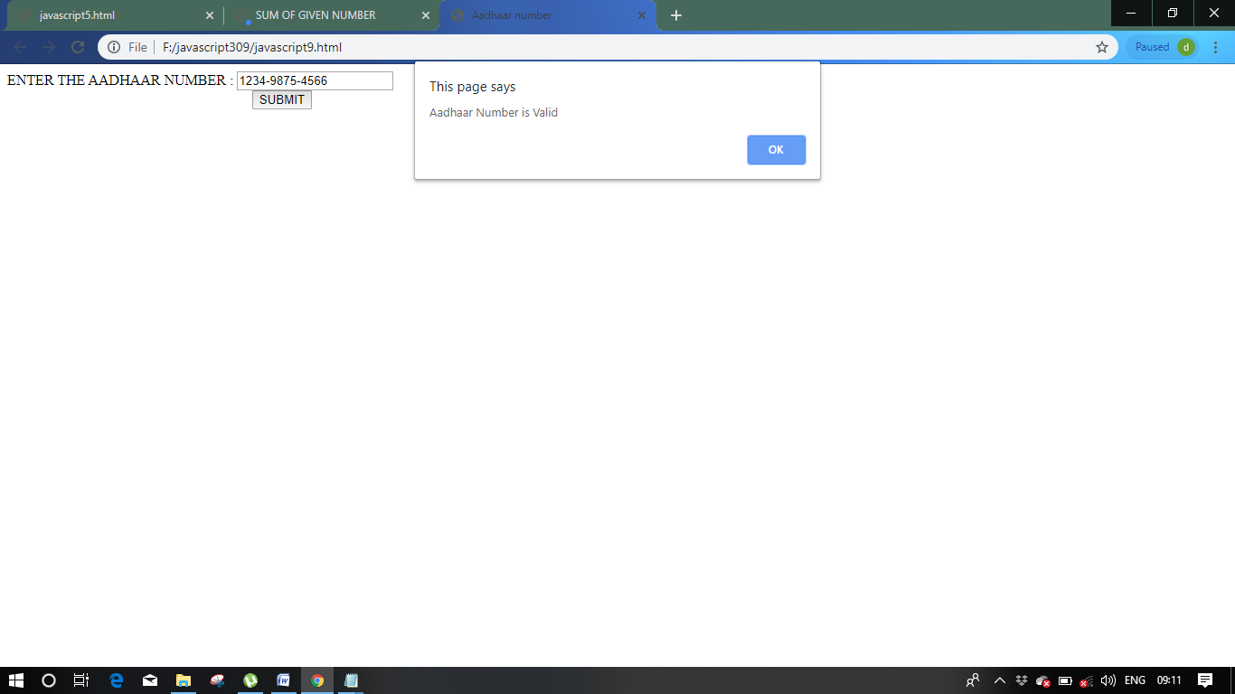

**Result:**

Hence we successfully Developed a webpage using Regular Expression

|  |  |
| --- | --- |
| **Ex no: 14** | **Developinhg a webpage using Regular Expression** |
| **Date :** |

**Question:2**

Write a JavaScript function that checks occurence of substring in a given string

**Aim:**

To Write a JavaScript function that checks occurence of substring in a given string

**Code:**

**<!DOCTYPE html>**

**<html>**

**<head>**

**<title>JAVA SCRIPT</title>**

**</head>**

**<body>**

**<script type="text/javascript">**

**function Phone_num()**

**{**

**phone_number= Number(document.getElementById("phone_number").value);**

**var valid_num= /\d{10}$/;**

**var res =valid_num.exec(phone_number);**

**if(res)**

**{**

**window.alert("Phone Number is Valid");**

**}**

**else{**

**window.alert("Phone Number is Invalid \n PLEASE CHECK");**

**}**

**}**

**function Email()**

**{**

**mail= String(document.getElementById("mail").value);**

**var valid_mail= /^(\S)+@([A-Za-z]{3,6})?(.[a-zA-Z]{2,5})+.[a-z]{2,4}$/;**

**var res =valid_mail.exec(mail);**

**if(res)**

**{**

**window.alert("Mail ID is Valid");**

**}**

**else{**

**window.alert("Mail ID is Invalid \n PLEASE CHECK");**

**}**

**}**

**</script>**

**ENTER THE PHONE_NO : <input type="text" name="phone_number" id="phone_number"/>**

**<center><button onClick="Phone_num()">SUBMIT</button></center><br><br>**

**ENTER THE MAIL_ID : <input type="text" name="mail" id="mail"/>**

**<center><button onClick="Email()">SUBMIT</button>**

**</body>**

**</html>**

**Output:**

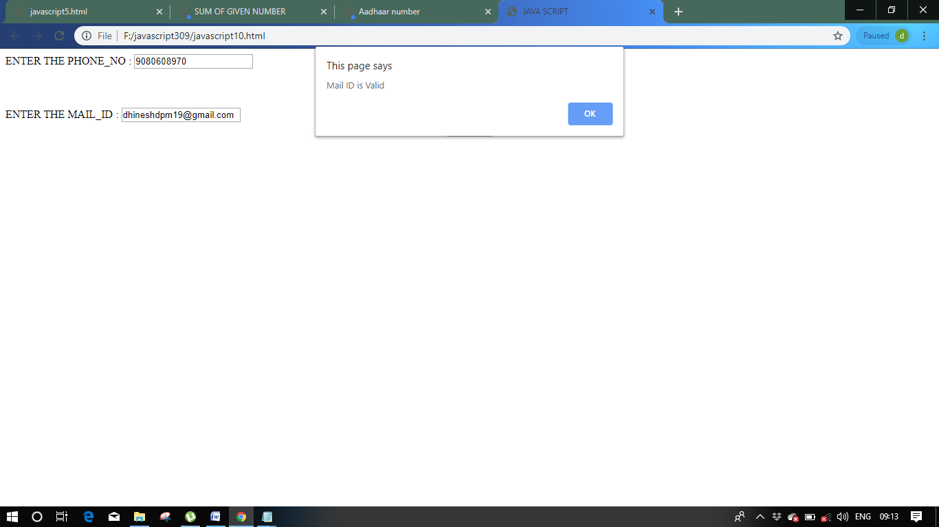

**Result:**

Hence we successfully Developed a webpage using Regular Expression

|  |  |
| --- | --- |
| **Ex no: 15** | **Creating XML document for given data** |
| **Date :** |

**Question:1**

Create XML document for the following data: Student Registration Form Name Rahul Age 16 Gender Male Course C Programming

**Aim:**

To Create XML document for the following data: Student Registration Form Name Rahul Age 16 Gender Male Course C Programming

**Code:**

**<<?xml version="1.0" ?>**

**<StudentRegistrationForm>**

**<name>Rahul</name>**

**<Age>"16></Age>**

**<Gender>Male</Gender>**

**<Course>C Programming</Course>**

**</StudentRegistrationForm>**

**</html>**

**Output**

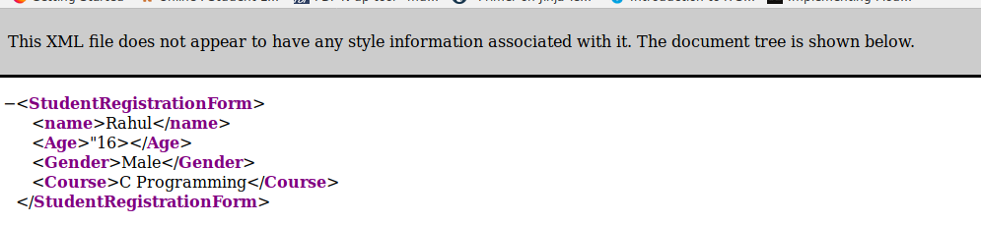

**Result:**

Hence we successfully Created XML document for given data

|  |  |
| --- | --- |
| **Ex no: 15** | **Creating XML document for given data** |
| **Date :** |

**Question:2**

Check whether the following XML documents are well formed. If it is not well formed, correct the errors. <?xml version="1.0" encoding="iso-8859-1"?> <message> <email> <header> <sender>me@wipro.com</sender> <recipient>you@wipro.com</recipient> </header> <subject>Re: XML </subject> <text>I'm working on XML now. </email> </Messag

**Aim:**

To Check whether the following XML documents are well formed

**Code:**

**<<?xml version="1.0" encoding="iso-8859-1"?>**

**<message>**

**<email>**

**<header>**

**<sender>me@wipro.com</sender>**

**<recipient>you@wipro.com</recipient>**

**</header>**

**<subject>Re: XML </subject>**

**<text>I'm working on XML now.</text>**

**</email>**

**</message>**

**Output**

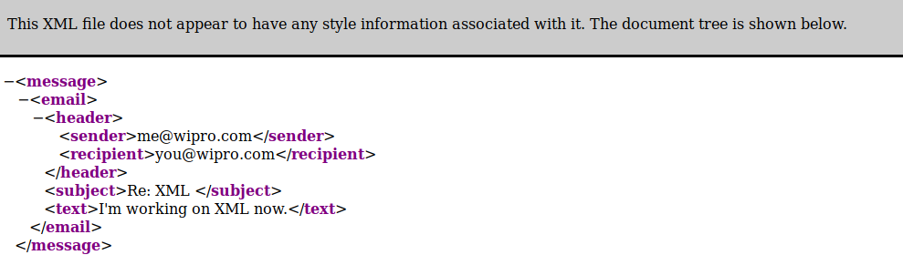

**Result:**

Hence we successfully Created XML document for given data

|  |  |
| --- | --- |
| **Ex no: 15** | **Creating XML document for given data** |
| **Date :** |

**Question:3**

Develop DTD for the below given XML document: <address> <name>Manju</name> <company>Wipro</company> <phone>9988776655</phone> </address>

**Aim:**

To Develop DTD for the below given XML document: <address> <name>Manju</name> <company>Wipro</company> <phone>9988776655</phone> </address>

**Code:**

**<?xml version="1.0"?>**

**<!DOCTYPE note [**

**<!ELEMENT address (name,company,phone)>**

**<!ELEMENT name (#PCDATA)>**

**<!ELEMENT company (#PCDATA)>**

**<!ELEMENT phone (#PCDATA)>**

**]>**

**<address>**

**<name>Manju</name>**

**<company>Wipro</company>**

**<phone>"9092191952"</phone>**

**</address>**

**Output:**

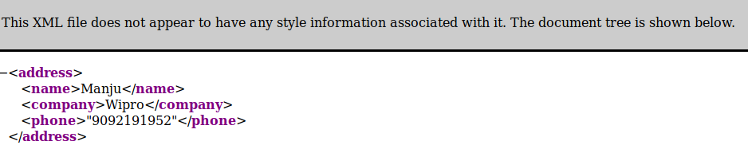

**Result:**

Hence we successfully Created XML document for given data

|  |  |
| --- | --- |
| **Ex no: 16** | **Develop a DTD file for given XML document** |
| **Date :** |

**Question:1**

Develop DTD file for the below given XML document:  
<?xml version="1.0"?>  
<?xml-stylesheet href="catalog.xsl" type="text/xsl"?>  
<!DOCTYPE catalog SYSTEM "catalog.dtd">  
<catalog>  
<product description="Cardigan Sweater" product_image="cardigan.jpg">  
<catalog_item gender="Men's">  
<item_number>QWZ5671</item_number>  
<price>39.95</price>  
<size description="Medium">  
<color_swatch image="red_cardigan.jpg">Red</color_swatch>  
<color_swatch image="burgundy_cardigan.jpg">Burgundy</color_swatch>  
</size>  
<size description="Large">  
<color_swatch image="red_cardigan.jpg">Red</color_swatch>  
<color_swatch image="burgundy_cardigan.jpg">Burgundy</color_swatch>  
</size>  
</catalog_item>  
<catalog_item gender="Women's">  
<item_number>RRX9856</item_number>  
<price>42.50</price>  
<size description="Small">  
<color_swatch image="red_cardigan.jpg">Red</color_swatch>  
<color_swatch image="navy_cardigan.jpg">Navy</color_swatch>  
<color_swatch image="burgundy_cardigan.jpg">Burgundy</color_swatch>  
</size>  
<size description="Medium">  
<color_swatch image="red_cardigan.jpg">Red</color_swatch>  
<color_swatch image="navy_cardigan.jpg">Navy</color_swatch>  
<color_swatch image="burgundy_cardigan.jpg">Burgundy</color_swatch>  
<color_swatch image="black_cardigan.jpg">Black</color_swatch>  
</size>  
<size description="Large">  
<color_swatch image="navy_cardigan.jpg">Navy</color_swatch>  
<color_swatch image="black_cardigan.jpg">Black</color_swatch>  
</size>  
<size description="Extra Large">  
<color_swatch image="burgundy_cardigan.jpg">Burgundy</color_swatch>  
<color_swatch image="black_cardigan.jpg">Black</color_swatch>  
</size>  
</catalog_item>  
</product>  
</catalog>

**Aim:**

To Develop DTD file for the above given XML document:

**Code:**

**<<?xml version="1.0" encoding="UTF-8"?>**

**<?xml-stylesheet href="4.xsl" type="text/xsl"?>**

**<!DOCTYPE catalog SYSTEM "4.dtd">**

**<catalog>**

**<product description="Cardigan Sweater" product_image="cardigan.jpg">**

**<catalog_item gender="Men's">**

**<item_number>QWZ5671</item_number>**

**<price>39.95</price>**

**<size description="Medium">**

**<color_swatch image="rose-blue-flower-rose-blooms-67636.jpg">Red</color_swatch>**

**<color_swatch image="burgundy_cardigan.jpg">Burgundy</color_swatch>**

**</size>**

**<size description="Large">**

**<color_swatch image="red_cardigan.jpg">Red</color_swatch>**

**<color_swatch image="burgundy_cardigan.jpg">Burgundy</color_swatch>**

**</size>**

**</catalog_item>**

**<catalog_item gender="Women's">**

**<item_number>RRX9856</item_number>**

**<price>42.50</price>**

**<size description="Small">**

**<color_swatch image="red_cardigan.jpg">Red</color_swatch>**

**<color_swatch image="navy_cardigan.jpg">Navy</color_swatch>**

**<color_swatch image="burgundy_cardigan.jpg">Burgundy</color_swatch>**

**</size>**

**<size description="Medium">**

**<color_swatch image="red_cardigan.jpg">Red</color_swatch>**

**<color_swatch image="navy_cardigan.jpg">Navy</color_swatch>**

**<color_swatch image="burgundy_cardigan.jpg">Burgundy</color_swatch>**

**<color_swatch image="black_cardigan.jpg">Black</color_swatch>**

**</size>**

**<size description="Large">**

**<color_swatch image="navy_cardigan.jpg">Navy</color_swatch>**

**<color_swatch image="black_cardigan.jpg">Black</color_swatch>**

**</size>**

**<size description="Extra Large">**

**<color_swatch image="burgundy_cardigan.jpg">Burgundy</color_swatch>**

**<color_swatch image="black_cardigan.jpg">Black</color_swatch>**

**</size>**

**</catalog_item>**

**</product>**

**</catalog>**

**Output**



**Result:**

Hence we successfully Developed a DTD file for given XML document

|  |  |
| --- | --- |
| **Ex no: 16** | **Develop a DTD file for given XML document** |
| **Date :** |

**Question:2**

Develop an XML file following the DTD file given below:  
<!DOCTYPE TVSCHEDULE [  
<!ELEMENT TVSCHEDULE (CHANNEL+)>  
<!ELEMENT CHANNEL (BANNER,DAY+)>  
<!ELEMENT BANNER (#PCDATA)>  
<!ELEMENT DAY (DATE,(HOLIDAY|PROGRAMSLOT+)+)>  
<!ELEMENT HOLIDAY (#PCDATA)>  
<!ELEMENT DATE (#PCDATA)>  
<!ELEMENT PROGRAMSLOT (TIME,TITLE,DESCRIPTION?)>  
<!ELEMENT TIME (#PCDATA)>  
<!ELEMENT TITLE (#PCDATA)>  
<!ELEMENT DESCRIPTION (#PCDATA)>  
<!ATTLIST TVSCHEDULE NAME CDATA #REQUIRED>  
<!ATTLIST CHANNEL CHAN CDATA #REQUIRED>  
<!ATTLIST PROGRAMSLOT VTR CDATA #IMPLIED>  
<!ATTLIST TITLE RATING CDATA #IMPLIED>  
<!ATTLIST TITLE LANGUAGE CDATA #IMPLIED>  
]>

**Aim:**

To Develop an XML file following the DTD file given above

**Code:**

**<?xml version="1.0"?>**

**<!DOCTYPE TVSCHEDULE [**

**<!ELEMENT TVSCHEDULE (CHANNEL+)>**

**<!ELEMENT CHANNEL (BANNER,DAY+)>**

**<!ELEMENT BANNER (#PCDATA)>**

**<!ELEMENT DAY (DATE,(HOLIDAY|PROGRAMSLOT+)+)>**

**<!ELEMENT HOLIDAY (#PCDATA)>**

**<!ELEMENT DATE (#PCDATA)>**

**<!ELEMENT PROGRAMSLOT (TIME,TITLE,DESCRIPTION?)>**

**<!ELEMENT TIME (#PCDATA)>**

**<!ELEMENT TITLE (#PCDATA)>**

**<!ELEMENT DESCRIPTION (#PCDATA)>**

**<!ATTLIST TVSCHEDULE NAME CDATA #REQUIRED>**

**<!ATTLIST CHANNEL CHAN CDATA #REQUIRED>**

**<!ATTLIST PROGRAMSLOT VTR CDATA #IMPLIED>**

**<!ATTLIST TITLE RATING CDATA #IMPLIED>**

**<!ATTLIST TITLE LANGUAGE CDATA #IMPLIED>**

**]>**

**<TVSCHEDULE NAME="vehicle launch">**

**<CHANNEL CHAN="111">**

**<BANNER> APACHE </BANNER>**

**<DAY>**

**<DATE>11/12/2019</DATE>**

**<HOLIDAY> YES </HOLIDAY>**

**<PROGRAMSLOT VTR="333">**

**<TIME RATING="7.9">10:35a.m</TIME>**

**<TITLE LANGUAGE="english"> HAHAHAH </TITLE>**

**<DESCRIPTION > BIKE REVIEWS </DESCRIPTION>**

**</PROGRAMSLOT>**

**</DAY>**

**</CHANNEL>**

**</TVSCHEDULE>**

**Output**

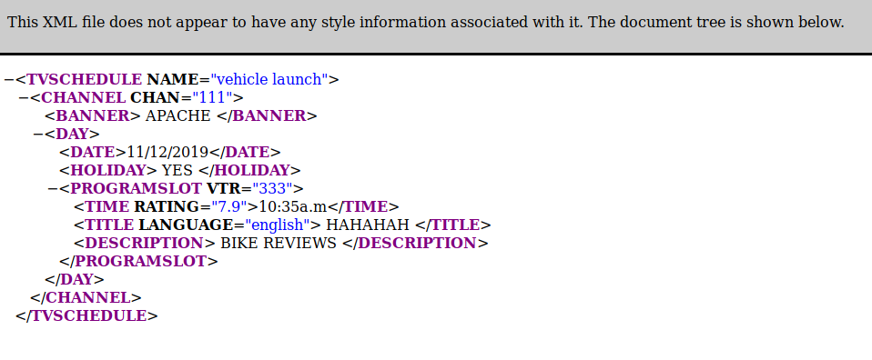

**Result:**

Hence we successfully Developed a DTD file for given XML document

|  |  |
| --- | --- |
| **Ex no: 17** | **Developing a XML document to avoid Naming conflits** |
| **Date :** |

**Question:1**

Avoid Naming conflict in the following XML document:  
<Phone>  
<name>Moto E</name>  
<ModelNo>123</ModelNo>  
<Processor> Qualcomm Snapdragon 200 </Processor>  
<Battery>2390 mAh</Battery>  
</Phone>  
<Phone>  
<name>Beetel M71 Landline</name>  
<ModelNo>456</ModelNo>  
<Display>LCD Screen</Display>  
<Corded>Yes</Corded>  
</Phone>

**Aim:**

To Avoid Naming conflict in the above XML document:

**Code:**

**<?xml version="1.0" encoding="UTF-8"?>**

**<Phone>**

**<s1:mobile xmlns:s1 = "www.google.com">**

**<s1:name>Moto E</s1:name>**

**<s1:ModelNo>123</s1:ModelNo>**

**<s1:Processor> Qualcomm Snapdragon 200 </s1:Processor>**

**<s1:Battery>2390 mAh</s1:Battery>**

**</s1:mobile>**

**<s2:mobile1 xmlns:s2 = "www.google.com">**

**<s2:name>Beetel M71 Landline</s2:name>**

**<s2:ModelNo>456</s2:ModelNo>**

**<s2:Display>LCD Screen</s2:Display>**

**<s2:Corded>Yes</s2:Corded>**

**</s2:mobile1>**

**</Phone>**

**Output**

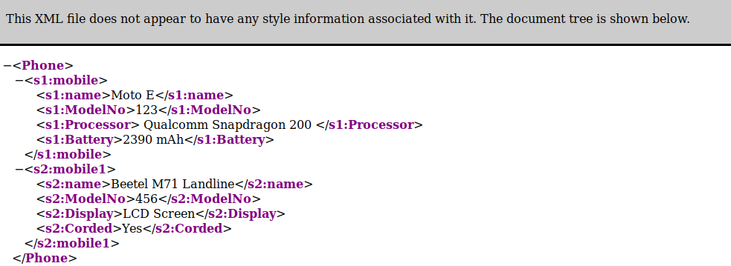

**Result:**

Hence we successfully Developed a XML document to avoid Naming conflits

|  |  |
| --- | --- |
| **Ex no: 18** | **Develop a Schema file for a given XML file** |
| **Date :** |

**Question:1**

Create and XSD file for the XML document given in the DTD

**Aim:**

To Create and XSD file for the XML document given in the DTD

**Code:**

**<?xml version="1.0" ?>**

**<xs:schema xmlns:xs="http://www.w3.org/20001/XMLSchema.com">**

**<xs:element name="StudentRegistrationForm">**

**<xs:complexType>**

**<xs:sequence>**

**<xs:element name="name" type="xs:string"/>**

**<xs:element name="age" type="xs:int"/>**

**<xs:element name="Gender" type="xs:string"/>**

**<xs:element name="Course" type="xs:string"/>**

**</xs:sequence>**

**</xs:complexType>**

**</xs:element>**

**</xs:schema>**

**Output:**

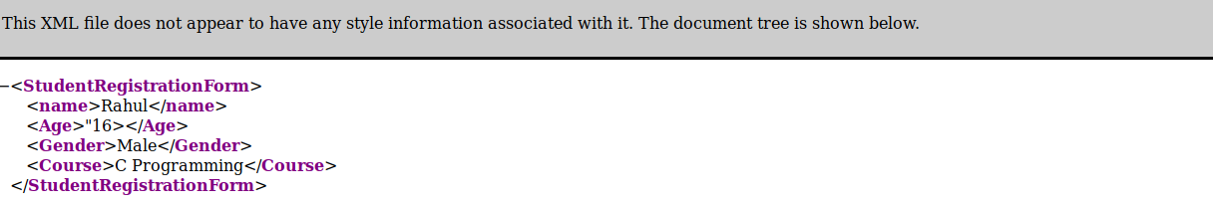

**Result:**

Hence we successfully Developed a Schema file for a given XML file

|  |  |
| --- | --- |
| **Ex no: 18** | **Develop a Schema file for a given XML file** |
| **Date :** |

**Question:2**

Create an XSD file for the XML document given in the DTD

**Aim:**

To Create an XSD file for the XML document given in the DTD

**Code:**

**<?xml version="1.0" ?>**

**<xs:schema xmlns:xs="http://www.w3.org/20001/XMLSchema.com">**

**<xs:element name="message">**

**<xs:complexType>**

**<xs:sequence>**

**<xs:element name="email">**

**<xs:complexType>**

**<xs:sequence>**

**<xs:element name="sender" type="xs:string"/>**

**<xs:element name="recipient" type="xs:string"/>**

**</xs:sequence>**

**</xs:complexType>**

**</xs:element>**

**<xs:element name="subject" type="xs:string"/>**

**<xs:element name="text" type="xs:string"/>**

**</xs:sequence>**

**</xs:complexType>**

**</xs:element>**

**</xs:schema>**

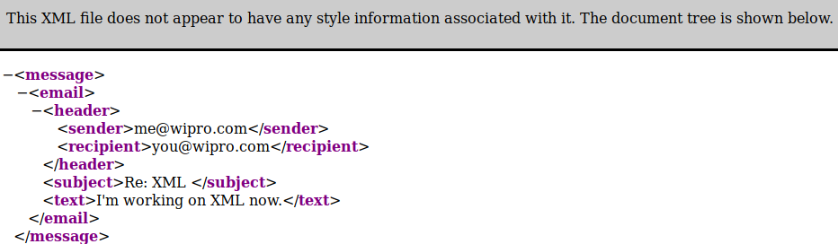**Output:**

**Result:**

Hence we successfully Developed a Schema file for a given XML file

|  |  |
| --- | --- |
| **Ex no: 19** | **Develop a webpage using Flask with HTML** |
| **Date :** |

**Question:1**

Design the following web page using Flask with HTML and render it for the route ‘/details’

**Aim::**

To Design the following web page using Flask with HTML and render it for the route ‘/details’

**Code:**

**from flask import Flask, render_template**

**app = Flask(__name__)**

**@app.route('/')**

**def main():**

**return render_template('hello.html')**

**if __name__ == '__main__':**

**app.run(debug = True)**

**HELLO.HTML:**

**<!DOCTYPE html>**

**<html lang="en">**

**<head>**

**<meta charset="utf-8">**

**<title>Say hello</title>**

**</head>**

**<body>**

**<form>**

**<p> Title<select ><option value="volvo">Mr</option>**

**<option value="saab">Mrs</option></select></p>**

**<p>Name <input type='text' placeholder='Name'></p>**

**<p>City <input type='text' placeholder='City'></p>**

**<p>Country <input type='text' placeholder='Country'></p>**

**<p>Telephone <input type='text' placeholder='Telephone'></p>**

**<p>Please Inform us of your interest</p>**

**<input type="checkbox" name="vehicle1" value="Bike">Sports<br>**

**<input type="checkbox" name="vehicle2" value="Car">Music<br>**

**<input type="checkbox" name="vehicle3" value="Boat" >reading<br>**

**<input type="checkbox" name="vehicle3" value="Boat">Tv and Flim<br>**

**<p>Your Age</p>**

**<input type="radio" name="gender" value="male" checked>Less Than 25**

**<input type="radio" name="gender" value="female">26-40**

**<input type="radio" name="gender" value="other">41-65**

**<input type="radio" name="gender" value="other1">Over 65<br><br>**

**<input type="submit" value="submit">**

**</body>**

**</html>**

**Output**

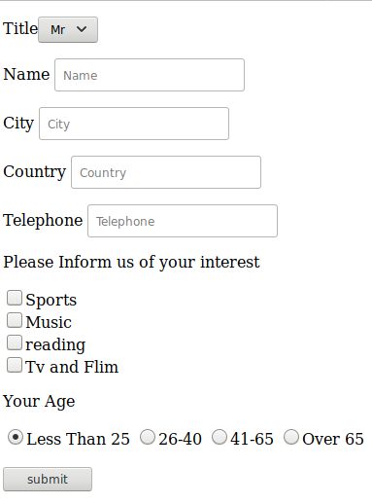

**Result:**

Hence we successfully Developed a webpage using Flask with HTML

|  |  |
| --- | --- |
| **Ex no: 19** | **Develop a webpage using Flask with HTML** |
| **Date :** |

**Question:2**

Develop a web application using Flask based on the following routes:

|  |  |
| --- | --- |
| /hello/ | Return the message “Good Morning!” |

**Aim:**

To Develop a web application using Flask based on the following routes:

**Code:**

**from flask import Flask**

**app = Flask(__name__)**

**@app.route('/hello/')**

**def hello():**

**return 'Good Morning !'**

**@app.route('/hello/<name>')**

**def hello1(name):**

**return '<h1>Good Morning! %s</h1>' %name**

**if __name__ == '__main__':**

**app.run(debug=True)**

**Output**

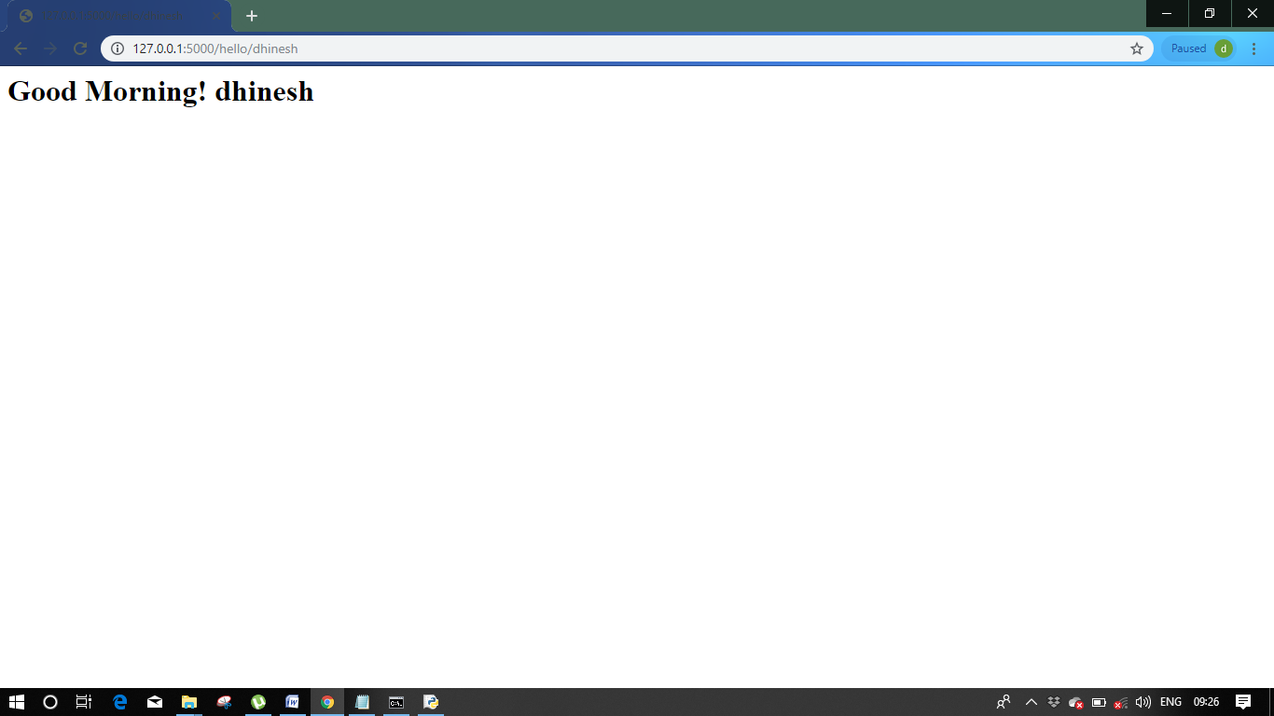

**Result:**

Hence we successfully Developed a webpage using Flask with HTML

|  |  |
| --- | --- |
| **Ex no: 20** | **Develop a webpage using Flask with HTML** |
| **Date :** |

**Question:1**

Design the following web page using Flask

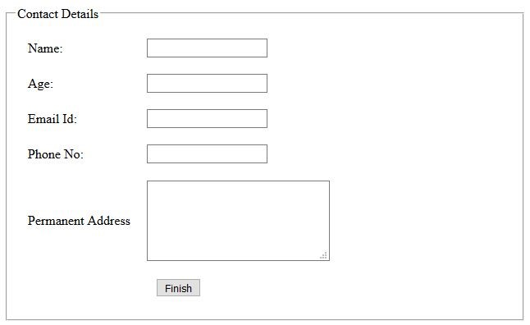

**Aim:**

To Design the following web page using Flask

**Code:**

**from flask import \***

**app = Flask(__name__)**

**app.secret_key = "abc"**

**@app.route('/')**

**def home():**

**return render_template("home.html")**

**@app.route('/login')**

**def login():**

**return render_template("login.html")**

**@app.route('/success',methods = ["POST"])**

**def success():**

**if request.method == "POST":**

**session['name']=request.form['name']**

**session['age']=request.form['age']**

**session['email']=request.form['email']**

**session['phone']=request.form['phone']**

**session['address']=request.form['address']**

**return render_template('success.html')**

**@app.route('/logout')**

**def logout():**

**if 'email' in session:**

**session.pop('email',None)**

**return render_template('logout.html');**

**else:**

**return '<p><b>User already Logged Out !!..</b></p>'**

**@app.route('/profile')**

**def profile():**

**if 'email' in session:**

**name=session['name']**

**age= session['age']**

**email=session['email']**

**phone=session['phone']**

**address=session['address']**

**return render_template('profile.html',name=name,age=age,email=email,phone=phone,address=address)**

**else:**

**return '<p><b>Please Login First !!..</b></p>'**

**if __name__ == '__main__':**

**app.run(debug = True,port=6654)**

**Output:**

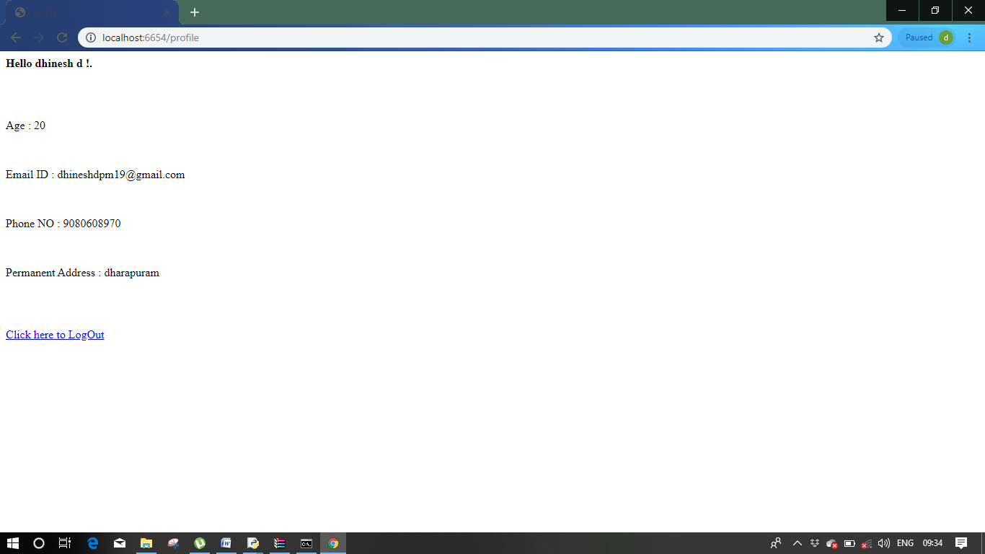

**Result:**

Hence we successfully Developed a webpage using Flask with HTML

|  |  |
| --- | --- |
| **Ex no: 20** | **Develop a webpage using Flask with HTML** |
| **Date :** |

**Question:2**

Write a JavaScript function to remove specified number of characters from a string

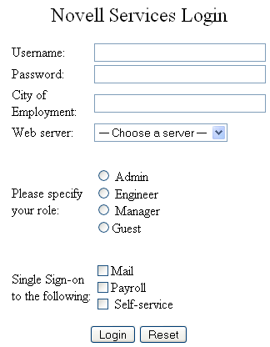

**Aim:**

Design the HTML form given below and render it for the route ‘**/services’**

**Code:**

**from flask import Flask, render_template**

**app = Flask(__name__)**

**@app.route('/')**

**def main():**

**return render_template('hello1.html')**

**if __name__ == '__main__':**

**app.run(debug = True)**

**HELLO.HTML:**

**<!DOCTYPE html>**

**<html lang="en">**

**<head>**

**<meta charset="utf-8">**

**<title>Say hello</title>**

**</head>**

**<body>**

**<form>**

**<p> Title<select ><option value="volvo">Mr</option>**

**<option value="saab">Mrs</option></select></p>**

**<p>Name <input type='text' placeholder='Name'></p>**

**<p>City <input type='text' placeholder='City'></p>**

**<p>Country <input type='text' placeholder='Country'></p>**

**<p>Telephone <input type='text' placeholder='Telephone'></p>**

**<p>Please Inform us of your interest</p>**

**<input type="checkbox" name="vehicle1" value="Bike">Sports<br>**

**<input type="checkbox" name="vehicle2" value="Car">Music<br>**

**<input type="checkbox" name="vehicle3" value="Boat" >reading<br>**

**<input type="checkbox" name="vehicle3" value="Boat">Tv and Flim<br>**

**<p>Your Age</p>**

**<input type="radio" name="gender" value="male" checked>Less Than 25**

**<input type="radio" name="gender" value="female">26-40**

**<input type="radio" name="gender" value="other">41-65**

**<input type="radio" name="gender" value="other1">Over 65<br><br>**

**<input type="submit" value="submit">**

**</body>**

**</html>**

**Output:**

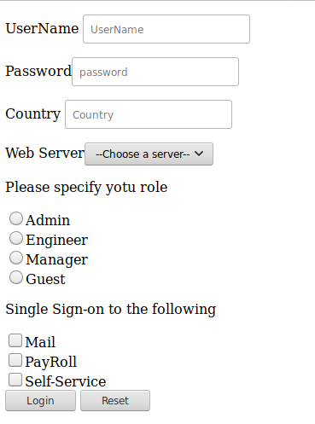

**Result:**

Hence we successfully Developed a webpage using Flask with HTML

|  |  |
| --- | --- |
| **Ex no: 21** | **Design the given webpage using macros in jinga** |
| **Date :** |

**Question:1**

C*reate a webpage to print your name on the screen with every letter having a different heading size.*

(ii)Create a webpage that prints two lists with any information you want. One list should be an ordered list and the other list should be an unordered list

(iii)Create a webpage that will display an image that has a border of size 2, a width of 200px, and a height of 200px.

(iV)D*evelop a webpage to display the table having the columns (highlighted) as Decimal, English, Spanish, Korean, and Binary. Following are the data to be in each rows respective of their columns :*

**Aim:**

To Create an HTML page with flask with above condition

**Code:**

|  |  |
| --- | --- |
|  | **<!DOCTYPE html>** |
|  | **<html>** |
|  | **<head>** |
|  | **<meta charset="ISO-8859-1">** |
|  | **<title>FLASK_EX_1</title></head>** |
|  | **<body>** |
|  |  |
|  | **<form name='detailForm' action="/detail" method="post">** |
|  | **<p>Please Complete the Form. Mandatory Fields are marked with a<span style='color:red'> *</span></p><br>** |
|  | **<fieldset>** |
|  | **<legend>CONTACT DETAILS</legend>** |
|  | **<table>** |
|  | **<tr>** |
|  | **<td>Name<span style='color:red'> *</span></td>** |
|  | **<td>** |
|  | **<input type='text' name='name' value='' required />** |
|  | **</td>** |
|  | **</tr>** |
|  | **<tr>** |
|  | **<td>Telephone </td>** |
|  | **<td>** |
|  | **<input type='text' name='phone' value='' required />** |
|  | **</td>** |
|  | **</tr>** |
|  | **<tr>** |
|  | **<td>EMail<span style='color:red'> *</span></td>** |
|  | **<td>** |
|  | **<input type='email' name='mail' value='' required />** |
|  | **</td>** |
|  | **</tr>** |
|  | **</table>** |
|  | **</fieldset>** |
|  | **<fieldset>** |
|  | **<legend>PERSONAL INFORMATIONS</legend>** |
|  | **<table>** |
|  | **<tr>** |
|  | **<td><span style='color:red'> *</span> Age </td>** |
|  | **<td>** |
|  | **<input type='text' name='age' value='' required />** |
|  | **</td>** |
|  | **</tr>** |
|  | **<tr>** |
|  | **<td>Gender </td>** |
|  | **<td>** |
|  | **<select name='gender'>** |
|  | **<option value=''>-- Choose your Gender --</option>** |
|  | **<option value='Male'>Male</option>** |
|  | **<option value='Female'>Female</option>** |
|  | **<option value='Other'>Other</option>** |
|  | **</select>** |
|  | **</td>** |
|  | **</tr>** |
|  | **<tr>** |
|  | **<td>When did you<br>First know you <br>Wanted to be a <br>Zoo-Keeper?</td>** |
|  | **<td>** |
|  | **<input type='text' name='zoo' value='' required />** |
|  | **</td>** |
|  | **</tr>** |
|  | **</table>** |
|  | **</fieldset>** |
|  | **<fieldset>** |
|  | **<legend>PICK YOUR FAVORITE ANIMALS</legend>** |
|  | **<input type='checkbox' name='anim' value='Zebra'/>Zebra** |
|  | **<input type='checkbox' name='anim' value='Cat'/>Cat** |
|  | **<input type='checkbox' name='anim' value='Anaconda'/>Anaconda** |
|  | **<input type='checkbox' name='anim' value='Human'/>Human<br>** |
|  | **<input type='checkbox' name='anim' value='Elephant'/>Elephant** |
|  | **<input type='checkbox' name='anim' value='Wildebeest'/>Wildebeest** |
|  | **<input type='checkbox' name='anim' value='Pigeon'/>Pigeon** |
|  | **<input type='checkbox' name='anim' value='Crap'/>Crap** |
|  | **</fieldset>** |
|  | **<input type = "submit" value = "Submit Application">** |
|  | **</form>** |
|  | **</body>** |
|  | **</html>** |

**Output:**

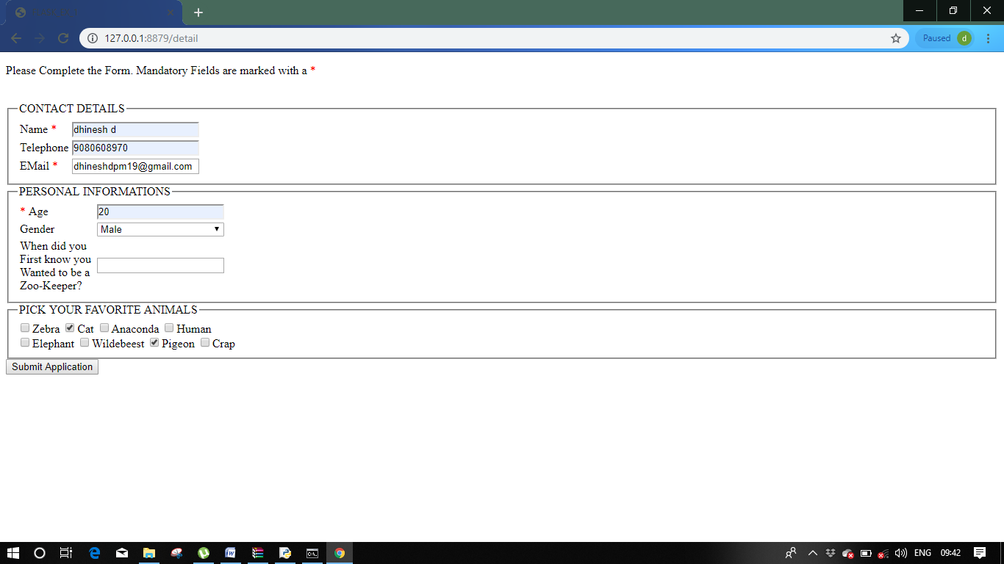

**Result:**

Hence we successfully Designed the given webpage using macros in jinga

|  |  |
| --- | --- |
| **Ex no: 22** | **Design the webpage using template inheritance** |
| **Date :** |

**Question:1**

D*esign a website for Ace Car Company based on the layout shown in figure [use template inheritance]:*

* Header.html – the header must contain the name of the company and a logo at the left.
* Home.html – should contain a brief description about the company.
* Cars.html – should contain a table describing at least 5 car details
* Contact.html – should contain the address, phone number, fax and email id of the company.
* Footer.html – the footer must contain a copyright information of the company.

**Aim:**

To Design a web page using a template inheritance

**Code:**

**CONTACT:**

|  |  |
| --- | --- |
|  | <!DOCTYPE html> |
|  | <html> |
|  | <body> |
|  | <h1>To Contact</h1> |
|  | <address> |
|  | Written by <a href="<mailto:webmaster@example.com>">Dhinesh</a>.<br> |
|  | Visit us at:<br> |
|  | https://www.nissan.in/vehicles/new/kicks/imd.html?utm_source=google&cid=psm_nissanseptemberoffer2019_awareness_google_imdbrand1&gclid=CjwKCAjw8ZHsBRA6EiwA7hw_sW_bI9MCnNrGWG8A0c4jsJza4X7jsZyFdSVa0a5o5UPfMJuiuW3YaxoCzgUQAvD_BwE<br> |
|  | Box 564, Disneyland<br> |
|  | USA |
|  | </address> |
|  |  |
|  |  |
|  |  |
|  | <footer> |
|  | <small>&copy; Copyright 2018, Example Corporation</small> |
|  | </footer> |
|  |  |
|  |  |
|  |  |
|  |  |
|  | <a href="[/](http://127.0.0.1:6757/)">Go Home</a> |
|  |  |
|  | </body> |
|  | </html> |

**HOME:**

|  |  |
| --- | --- |
|  | <!DOCTYPE html> |
|  | <html> |
|  | <head> |
|  | <title>Flask Template Example</title> |
|  | </head> |
|  | <body> |
|  |  |
|  |  |
|  | <!DOCTYPE html> |
|  | <html> |
|  | <head> |
|  | <meta name="viewport" content="width=device-width, initial-scale=1"> |
|  | <style> |
|  | * {box-sizing: border-box;} |
|  |  |
|  | body { |
|  | margin: 0; |
|  | font-family: Arial, Helvetica, sans-serif; |
|  | } |
|  |  |
|  | .header { |
|  | overflow: hidden; |
|  | background-color: #f1f1f1; |
|  | padding: 20px 10px; |
|  | } |
|  |  |
|  | .header a { |
|  | float: left; |
|  | color: black; |
|  | text-align: center; |
|  | padding: 12px; |
|  | text-decoration: none; |
|  | font-size: 18px; |
|  | line-height: 25px; |
|  | border-radius: 4px; |
|  | } |
|  |  |
|  | .header a.logo { |
|  | font-size: 25px; |
|  | font-weight: bold; |
|  | } |
|  |  |
|  | .header a:hover { |
|  | background-color: #ddd; |
|  | color: black; |
|  | } |
|  |  |
|  | .header a.active { |
|  | background-color: dodgerblue; |
|  | color: white; |
|  | } |
|  |  |
|  | .header-right { |
|  | float: right; |
|  | } |
|  |  |
|  | @media screen and (max-width: 500px) { |
|  | .header a { |
|  | float: none; |
|  | display: block; |
|  | text-align: left; |
|  | } |
|  |  |
|  | .header-right { |
|  | float: none; |
|  | } |
|  | } |
|  | </style> |
|  | </head> |
|  | <body> |
|  |  |
|  | <div class="header"> |
|  | <a href="<https://www.nissan-global.com/EN/index.html>" class="logo">Nissan</a> |
|  | <div class="header-right"> |
|  | <a class="active" href="[#home](http://127.0.0.1:6757/#home)">Home</a> |
|  | <a href="[/1](http://127.0.0.1:6757/1)">About</a> |
|  | <a href="[/2](http://127.0.0.1:6757/2)">Contact</a> |
|  |  |
|  | </div> |
|  | </div> |
|  |  |
|  | </body> |
|  | </html> |
|  |  |
|  |  |
|  |  |
|  |  |
|  | </body> |
|  | </html> |
|  |  | |
|  |  | |
|  |  | |
|  |  | |
|  |  | |
|  |  | |
|  |  | |
|  |  | |
|  |  | |
|  |  | |
|  |  | |
|  |  | |
|  |  | |
|  |  | |
|  |  | |
|  |  | |
|  |  | |
|  |  | |
|  |  | |
|  |  | |
|  |  | |
|  |  | |
|  |  | |
|  |  | |
|  |  | |
|  |  | |
|  |  | |
|  |  | |
|  |  | |
|  |  | |
|  |  | |
|  |  | |
|  |  | |
|  |  | |
|  |  | |
|  |  | |
|  |  | |

**Output:**

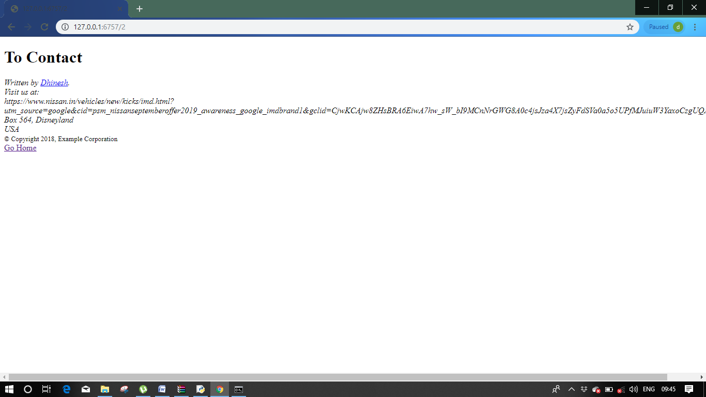

**Result:**

Hence we successfully Designed the webpage using template inheritance

|  |  |
| --- | --- |
| **Ex no: 23** | **Implementing relationships using Sqlalchemy** |
| **Date :** |

**Question:1**

Design an ORM for the given UML class diagram and also perform the following operations

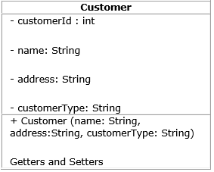

Create sequence for the customerId as 'seq_cust_id' starting with 5001. This field should be primary key .

2. Create and save 5 customer details.

3. Display the first record

4. Update the address of any customer .

5. Display customerId, name and customerType of all the customers.

6. Delete any two person from the table

**Aim::**

To Design an ORM for the given UML class diagram and also perform the following operations

**Code::**

**from sqlalchemy.ext.declarative import declarative_base**

**from sqlalchemy import \***

**from sqlalchemy.orm import \***

**from sqlalchemy import exc**

**Base = declarative_base()**

**class customer(Base):**

**__tablename__ = "customers"**

**cust_id = Column(Integer, Sequence('seq_cust_id', start=5001), primary_key=True)**

**name = Column(String(25))**

**address = Column(String(35))**

**customer_type= Column(String(20))**

**# Constructor**

**def __init__(self,cust_id,name,address,customer_type):**

**self.cust_id=cust_id**

**self.name = name**

**self.address = address**

**self.customer_type = customer_type**

**# Getters**

**def get_id(self):**

**return self.cust_id**

**def get_name(self):**

**return self.name**

**def get_address(self):**

**return self.address**

**def get_type(self):**

**return self.customer_type**

**# Setters**

**def set_id(self, value):**

**self.cust_id = value**

**def set_name(self, value):**

**self.name = value**

**def set_address(self, value):**

**self.address = value**

**def set_type(self, value):**

**self.customer_type = value**

**def __repr__(self):**

**return f"CUSTOMER ID = {self.get_id()}\nNAME = {self.get_name()}\nADDRESS = {self.get_address()}\nCUSTOMER TYPE = {self.get_type()}"**

**Session = sessionmaker()**

**engine=create_engine("oracle://mk:1@localhost:1521/XE")**

**Base.metadata.create_all(engine)**

**session = Session.configure(bind=engine)**

**session = Session()**

**li=[]**

**print('Enter Five id ')**

**for i in range(5):**

**li.append(input())**

**li1=[]**

**print('Enter Five Name ')**

**for i in range(5):**

**li1.append(input())**

**li2=[]**

**print('Enter Five address ')**

**for i in range(5):**

**li2.append(input())**

**li3=[]**

**print('Enter Five Customer type ')**

**for i in range(5):**

**li3.append(input())**

**obj=customer(li[0],li1[0],li2[0],li3[0])**

**obj1=customer(li[1],li1[1],li2[1],li3[1])**

**obj2=customer(li[2],li1[2],li2[2],li3[2])**

**obj3=customer(li[3],li1[3],li2[3],li3[3])**

**obj4=customer(li[4],li1[4],li2[4],li3[4])**

**session.add(obj)**

**session.add(obj1)**

**session.add(obj2)**

**session.add(obj3)**

**session.add(obj4)**

**session.commit()**

**#3**

**print('First Record')**

**print(session.query(customer).first())**

**session.commit()**

**print(session.query(customer).all())**

**#4**

**print('Update the address of any customer .')**

**session.query(customer).filter_by(name=li1[0]).update({customer.address:'Covai'})**

**session.commit()**

**qry=session.query(customer).all()**

**print(qry)**

**print('Display customerId, name and customerType of all the customers.')**

**qry=session.query(customer.cust_id,customer.name,customer.customer_type).all()**

**print(qry)**

**print("Delete any two person from the table ")**

**session.query(customer).filter_by(name=li1[0]).delete()**

**session.query(customer).filter_by(name=li1[0]).delete()**

**session.commit()**

**qry=session.query(customer).all()**

**print(qry)**

**session.close()**

**Output:**

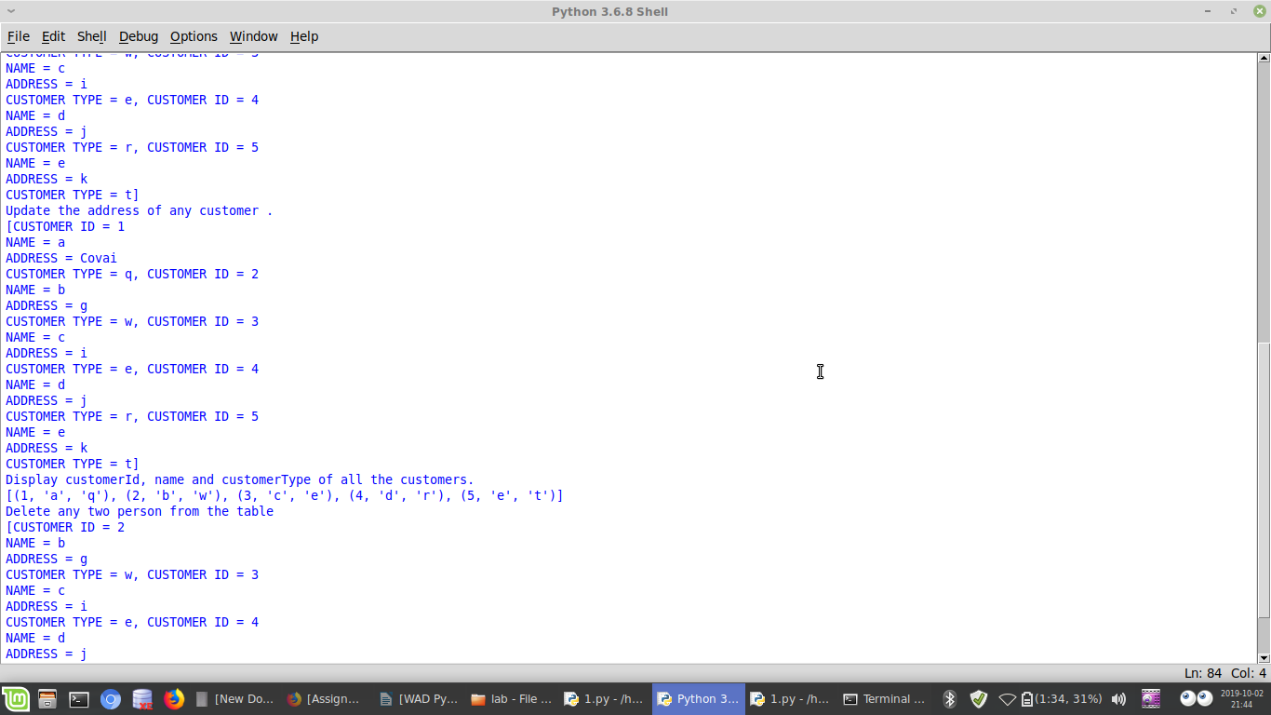

**Result:**

Thus web page has been successfully Implemented relationships using Sqlalchemy

|  |  |
| --- | --- |
| **Ex no: 23** | **Implementing relationships using Sqlalchemy** |
| **Date :** |

**Question:2**

Create a model class based on the one to many relationship given in the UML class diagram below and Insert all the details into the database using SQLAlchemy.

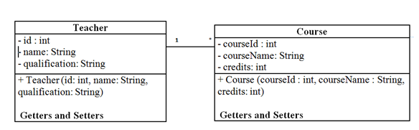

**Aim:**

To Create a model class based on the one to many relationship given in the UML class diagram below and Insert all the details into the database using SQLAlchemy.

**Code:**

**from sqlalchemy.ext.declarative import declarative_base**

**from sqlalchemy import \***

**from sqlalchemy.orm import \***

**from sqlalchemy import exc**

**Base = declarative_base()**

**class Teacher(Base):**

**__tablename__ = "teachers"**

**id = Column(Integer, Sequence('author_id_seq'), primary_key=True)**

**name = Column(String(50))**

**qualification=Column(String(50))**

**course_id=Column(Integer)**

**course_name=Column(String(50))**

**course_credit=Column(Integer,primary_key=True)**

**course= relationship("Course", back_populates="teacher")**

**class Course(Base):**

**__tablename__ = "course"**

**c_id = Column(Integer)**

**c_name = Column(String(50))**

**credits1= Column(Integer, ForeignKey('teachers.course_credit'))**

**author = relationship("Author", back_populates="book")**

**def __repr__(self):**

**return("Course_id={}/nCourse_name={}/nCredits={}".format(self.c_id,self.c_name,self.credits1))**

**Session = sessionmaker()**

**engine=create_engine("oracle://mk:1@localhost:1521/XE")**

**Base.metadata.create_all(engine)**

**session = Session.configure(bind=engine)**

**session = Session()**

**obj=Teacher(1,'mk','be',12,'som',13)**

**obj1=Course(199,'Mukesh')**

**session.add(obj)**

**session.commit()**

**#print(session.query(Author).all())**

**print(session.query(Book).all())**

**Output:**

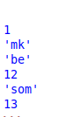

**Result:**

Thus web page has been successfully Implemented relationships using Sqlalchemy

|  |  |
| --- | --- |
| **Ex no: 24** | **Developing web application using Flask-SQLAlchemy** |
| **Date :** |

**Question:1**

Develop a web application for managing the Author details.

(i)Design a web page using HTML to read the Author details such as authorId,firstName and lastName.

(ii)Create a model class based on one to one relationship given in the UML class diagram below and Insert all the details into the database using Flask-SQLAlchemy.

**Aim:**

To Develop a web application for managing the Author details.

**Code:**

**from flask import \***

**from flask_sqlalchemy import \***

**from sqlalchemy import \***

**app = Flask(__name__)**

**app.config['SQLALCHEMY_DATABASE_URI'] = 'oracle://mk:1@localhost:1521/xe'**

**app.config['SQLALCHEMY_TRACK_MODIFICATIONS'] = True**

**db = SQLAlchemy(app)**

**class user97(db.Model):**

**__tablename__ = 'mk1'**

**id =db.Column(db.Integer,db.Sequence('seq_book',start=1001),primary_key=True)**

**f_n= db.Column(db.String(80))**

**l_n = db.Column(db.String(120))**

**title= db.Column(db.String(80))**

**b= db.Column(db.String(80))**

**@app.route("/")**

**def index():**

**return render_template("login.html")**

**@app.route("/register", methods=["GET", "POST"])**

**def register():**

**if request.method == "POST":**

**a= request.form['f_name']**

**b= request.form['l_name']**

**c= request.form['hi']**

**d=request.form['ti']**

**register = user97(f_n=a,l_n=b,title=d,b=c)**

**db.session.add(register)**

**db.session.commit()**

**return render_template("wel.html")**

**if __name__ == "__main__":**

**db.create_all()**

**app.run(debug=True)**

**INDEX.HTML**

**<!DOCTYPE html>**

**<html>**

**<head>**

**</head>**

**<body>**

**<form method="POST" action="/register">**

**<p>First Name</p>**

**<p>**

**<input type='text' name='f_name' />**

**</p>**

**<p>Last name</p>**

**<p>**

**<input type='text' name='l_name' />**

**</p>**

**<p>Book Id</p>**

**<p>**

**<input type='text' name='hi' />**

**</p>**

**<p>Title</p>**

**<p>**

**<input type='text' name='ti' />**

**</p>**

**<button type="submit" >Submit</button>**

**</div>**

**</form>**

**</body>**

**</html>**

**Output:**

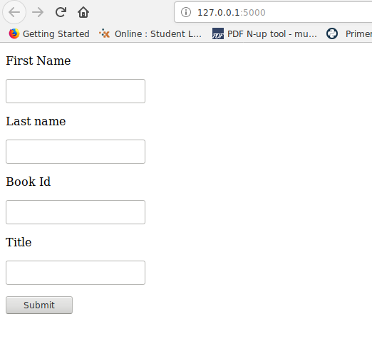

**Result:**

Thus we successfully Developed the web application using Flask-SQLAlchemy

|  |  |
| --- | --- |
| **Ex no: 24** | **Developing web application using Flask-SQLAlchemy** |
| **Date :** |

**Question:2**

Develop a web application for managing the Bank Account details of a customer in which one customer can have only one account. Design a web page using HTML to read the customer details such as name, address, phone number and account type (Savings or Salary).

**Aim:**

To Develop a web application for managing the Bank Account details of a customer in which one customer can have only one account. Design a web page using HTML to read the customer details such as name, address, phone number and account type (Savings or Salary).

**Code:**

**from flask import \***

**from flask_sqlalchemy import \***

**from sqlalchemy import \***

**app = Flask(__name__)**

**app.config['SQLALCHEMY_DATABASE_URI'] = 'oracle://mk:1@localhost:1521/xe'**

**app.config['SQLALCHEMY_TRACK_MODIFICATIONS'] = True**

**db = SQLAlchemy(app)**

**class user97(db.Model):**

**__tablename__ = 'mk2'**

**id =db.Column(db.Integer,db.Sequence('seq_book',start=1001),primary_key=True)**

**Name = db.Column(db.String(80))**

**Address = db.Column(db.String(120))**

**Phone= db.Column(db.String(80))**

**@app.route("/")**

**def index():**

**return render_template("register.html")**

**@app.route("/register", methods=["GET", "POST"])**

**def register():**

**if request.method == "POST":**

**uname = request.form['uname']**

**mail = request.form['mail']**

**passw = request.form['passw']**

**register = user97(Name= uname,Address= mail,Phone= passw)**

**db.session.add(register)**

**db.session.commit()**

**return render_template("wel.html")**

**if __name__ == "__main__":**

**db.create_all()**

**app.run(debug=True)**

**INDEX.HTML:**

**<!DOCTYPE html>**

**<html>**

**<head>**

**</head>**

**<body>**

**<form method="POST" method="POST" action="/register">**

**<p>Name</p>**

**<p>**

**<input type='text' name='uname' />**

**</p>**

**<p>Address</p>**

**<p>**

**<input type='text' name='mail' />**

**</p>**

**<p>PhoneNumber</p>**

**<p>**

**<input type='text' name='passw' />**

**</p>**

**<input type = "submit" value = "Submit">**

**</div>**

**</form>**

**</body>**

**</html>**

**Output:**

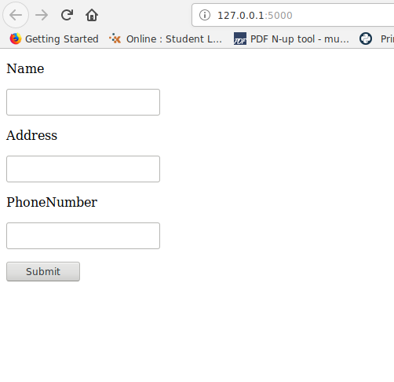

**Result:**

Thus we successfully Developed the web application using Flask-SQLAlchemy

|  |  |
| --- | --- |
| **Ex no: 24** | **Developing web application using Flask-SQLAlchemy** |
| **Date :** |

**Question:3**

Design the following web page using Flask-SQLAlchemy:

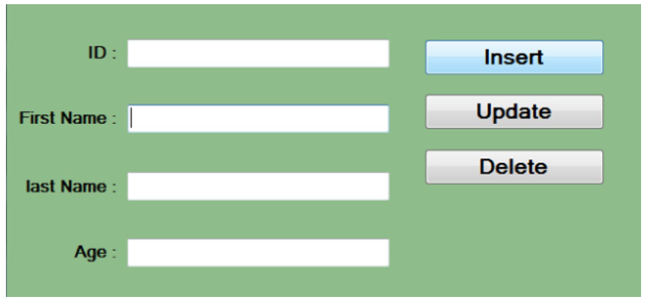

**Aim:**

To Design the following web page using Flask-SQLAlchemy:

**Code:**

**from flask.app import Flask**

**from flask.globals import request**

**from flask.templating import render_template**

**from flask_sqlalchemy import SQLAlchemy**

**app = Flask(__name__)**

**app.config['SQLALCHEMY_DATABASE_URI']='oracle://mk:1@localhost:1521/XE'**

**db=SQLAlchemy(app)**

**class Book(db.Model):**

**__tablename__ = 'books_tbl'**

**id =db.Column(db.Integer,db.Sequence('seq_book',start=1001),primary_key=True)**

**title=db.Column(db.String(25))**

**price=db.Column(db.Float)**

**author=db.relationship("Author",back_populates='book')**

**def __repr__(self):**

**return f"<Book(title={self.title},price=Rs.{self.price},author={self.author})>"**

**class Author(db.Model):**

**__tablename__='authors_tbl'**

**id = db.Column(db.Integer,db.Sequence('seq_author',start=5001),primary_key=True)**

**name=db.Column(db.String(20))**

**bookid = db.Column(db.Integer,db.ForeignKey('books_tbl.id'))**

**book = db.relationship("Book",back_populates='author')**

**def __repr__(self):**

**return f"<Author(name={self.name})>"**

**@app.route('/')**

**@app.route('/book',methods=['GET','POST'])**

**def book_store():**

**if request.method=='GET':**

**return render_template('bookstore.html')**

**elif request.method=='POST':**

**title=request.form['title']**

**author_name=request.form['author']**

**price=request.form['price']**

**option=request.form['option']**

**if option=='Add':**

**author=Author(name=author_name)**

**book=Book(title=title,author=[author],price=price)**

**db.session.add(book)**

**db.session.commit()**

**elif option=='Update':**

**book=Book.query.filter(Book.title==title).one()**

**book.price=price**

**db.session.commit()**

**elif option=='Delete':**

**book=Book.query.filter(Book.title==title).one()**

**db.session.delete(book)**

**db.session.commit()**

**else:**

**books=Book.query.all()**

**return render_template('show.html',books=books)**

**return render_template('bookstore.html')**

**if __name__=="__main__":**

**db.create_all()**

**app.run(debug=True)**

**Output**

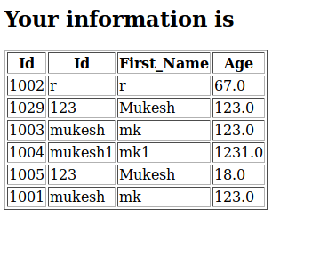

**Result:**

Thus we successfully Developed the web application using Flask-SQLAlchemy.